
REPUBLIC OF GHANA

COMPOSITE BUDGET

FOR 2021-2024

PROGRAMME BASED BUDGET ESTIMATES

FOR 2021

ASANTE AKIM CENTRAL MUNICIPAL ASSEMBLY

Table of Contents
PART A: STRATEGIC OVERVIEW 5
1. ESTABLISHMENT OF THE DISTRICT 5
Location and Size 6
2. VISION 10
3. MISSION 10
4. Core Values 10
5. GOALS 11
6. CORE FUNCTIONS 11
7. DISTRICT ECONOMY 12
a. AGRICULTURE 12
b. MARKET CENTER 19
e. HEALTH 23
SANITATION 37
f. ENERGY 41
8. KEY ACHIEVEMENTS IN 2020 42
9. REVENUE AND EXPENDITURE PERFORMANCE 56
a. REVENUE 56
b. EXPENDITURE 58
c. EXPENDITURE 59
ASANTE AKIM CENTRAL MUNICIAPL ASSEMBLY’S ADOPTED POLICY OBJECTIVES 60
13. POLICY OUTCOME INDICATORS AND TARGETS 61

15. REVENUE MOBILIZATION STRATEGIES FOR KEY REVENUE SOURCES 63
PART B: BUDGET PROGRAMME/SUB-PROGRAMME SUMMARY 64
PROGRAMME 1: MANAGEMENT AND ADMINISTRATION 64
SUB-PROGRAMME 1.1 General Administration 66
SUB-PROGRAMME 1.2 Finance and Revenue Mobilization 69
SUB-PROGRAMME 1.3 Planning, Budgeting and Coordination 72
SUB-PROGRAMME 1.3 Legislative Oversights 75
SUB-PROGRAMME 1.5 Human Resource Management 77
PROGRAMME 2: INFRASTRUCTURE DELIVERY AND MANAGEMENT 80
SUB-PROGRAMME 2.1 Physical and Spatial Planning 82
SUB-PROGRAMME 2.2 Infrastructure Development 86
PROGRAMME 3: SOCIAL SERVICES DELIVERY 89
SUB-PROGRAMME 3.1 Education and Youth Development 91
SUB-PROGRAMME 3.2 Health Delivery 94
SUB-PROGRAMME 3.3 Social Welfare and Community Development 98
SUB-PROGRAMME 3.4 Birth and Death Registration Services 102
PROGRAMME 4: ECONOMIC DEVELOPMENT 104
SUB-PROGRAMME 4.1 Trade, Tourism and Industrial Development 105
SUB-PROGRAMME 4.2 Agricultural Development 108
PROGRAMME 5: ENVIRONMENTAL MANAGEMENT 111
SUB-PROGRAMME 5.1 Disaster Prevention and Management 113
SUB-PROGRAMME 5.2 Natural Resource Conservation and Management 116

LIST OF TABLES
Table 1: Pupils - Teacher Ratio 14
Table 2: Medical Personnel 15
Table 3: Revenue Performance - IGF 30
Table 4: Revenue Performance - All Sources 31
Table 5: Expenditure Performance - All Sources 31
Table 6: NMTDF Policy Objectives 33
Table 7: Policy Outcome Indicators and Targets 37
Table 8: Budget Results Statement - Administration 43
Table 9: Main Operations and Projects 44
Table 10: Budget Results Statement - Finance and Revenue Mobilization 46
Table 11: Main Operations and Projects 47
Table 12: Budget Results Statement – Planning, Budgeting and Coordination 49
Table 13: Main Operations and Projects 50
Table 14: Budget Results Statement - Legislative Oversights 52
Table 15: Main Operations and Projects 52
Table 16: Budget Results Statement - Human Resource Management 54
Table 17: Main Operations and Projects 55
Table 18: Budget Results Statement – Physical and Spatial Planning 59
Table 19: Main Operations and Projects 60
Table 20: Budget Results Statement – Infrastructure Development 62
Table 21: Main Operations and Projects 63
Table 22: Budget Results Statement – Education and Youth Development 67
Table 23: Main Operations and Projects 68
Table 24: Budget Results Statement - Health Delivery 71
Table 25: Main Operations and Projects 72
Table 26: Budget Results Statement - Social Welfare and Community Development 74
Table 27: Main Operations and Projects 75
Table 28: Budget Results Statement – Birth and Death Registration Services 77
Table 29: Main Operations and Projects 77
Table 30: Budget Results Statement – Trade, Tourism and Industrial Development 81
Table 31: Main Operations and Projects 82
Table 32: Budget Results Statement - Agricultural Development 84
Table 33: Main Operations and Projects 85
Table 34: Budget Results Statement - Disaster Prevention and Management 88
Table 35: Main Operations and Projects 89
Table 36: Budget Results Statement - Natural Resource Conservation and Management 91
Table 37: Main Operations and Projects 92

PART A: STRATEGIC OVERVIEW

ESTABLISHMENT OF THE DISTRICT
  - Location and Size
A Municipality is usually a single urban administrative division having corporate status and powers of self -government or jurisdictions as granted by national and state laws, to which it is subordinate. It is to be distinguished from the country, which may encompass rural territory and/or numerous small communities such as towns, villages and hamlets.
The Asante Akim Central Municipal (formerly Asante Akim North Municipal) Assembly is one of the thirty (30) Districts in the Ashanti Region. It was created by Legislative Instrument (L.I) 2056 and it has Konongo – Odumasi as its twin Capital Town. It was carved out of the then Asante Akim District Council in 1988 and was elevated to Municipal status by L.I 1907 in November 2007. Until July 2012, it used to be Asante Akim North Municipal Assembly but with the carving out of the Asante Akim North District, the Municipal Assembly was re-named Asante Akim Central. For the purpose of decentralization and local government representation, the Municipality has one (1) electoral constituency for parliamentary representation, Twenty-five (25) electoral areas for Municipal Assembly representation and three (3) zonal councils (Konongo-Odumasi, Dwease-Praaso and Oweriagya councils).

Location and Size
The Asante Akim Central Municipal Assembly is located in the eastern part of the Ashanti Region. It shares boundaries with Asante Akim North District at the North, Ejisu-Juaben and Sekyere East at the West, Asante Akim South at the East and South. The land size of the Municipality is 400 square kilometres (km²) forming 1.6 % of the total land area of Ashanti region. The municipality is located within latitude 6 º 30’ north, 7 º30’ North, 0 º 15’ west and º 20’ west. Konongo – Odumasi is the Municipal Capital and it is about 48Km from Kumasi the Regional Capital. Other bigger settlements in the municipality include: Dwease, Praso, Patreansa, Nyaboo, Kyekyebiase, Obenimase. Figures, 1.3, and 1.4 show the Municipal Assembly in both National and Regional contexts respectively.
Population
The population of the Municipality, according to the 2010 Population and Housing Census is 71,508. This comprises of 33,942 males (47.5%) and 37,566 (52.5%) females. With a growth rate of 2.7%, the population of the municipality for the year 2020 is estimated to be 89,261

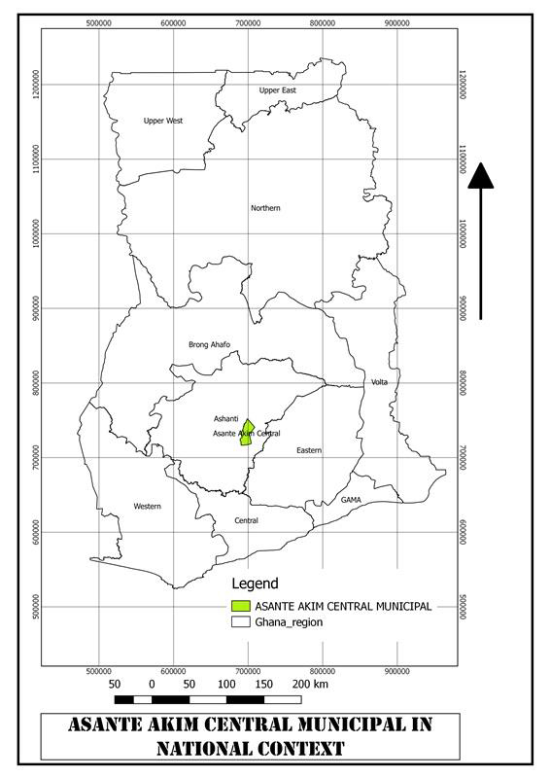
Figure 1.1: ASANTE AKIM CENTRAL IN NATIONAL CONTEXT

Source: A.A.N.D.A. 2018

Figure 1.2: ASANTE AKIM CENTRAL IN REGIONAL CONTEXT
As a nodal town, Konongo – Odumasi, is an area organized around a node, or focal point, and is defined by interactions or connections. The Municipal capital (Konongo-Odumasi) has the potential of developing into a large commercial hub of the region and further provides a higher order service to the surrounding communities which will relieve pressures on the regional capital. Figure 1.5 shows The Administrative Map of the Municipal Assembly.
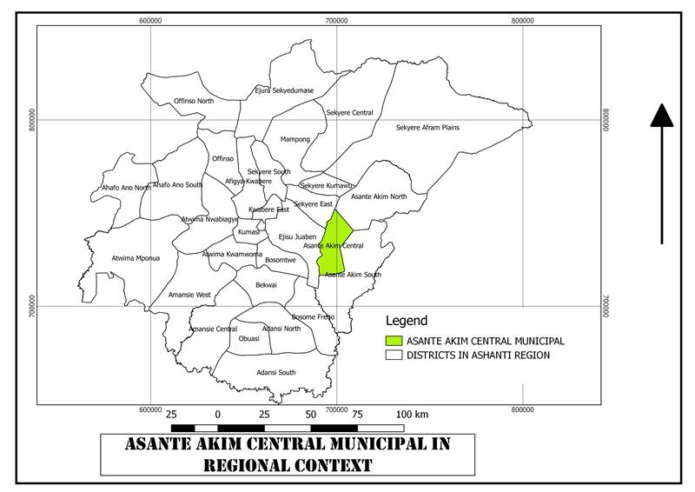

Source: A.A.N.D.A.

POPULATION STRUCTURE
The population of the Municipality, according to the 2010 Population and Housing Census is 71,508. This comprises of 33,942 males (47.5%) and 37,566 (52.5%) females. With a growth rate of 2.7%, the population of the municipality for the year 2020 is estimated to be 89,261.
(Source: GSS, 2010 PHC)

VISION
The Asante Akim Central Municipal Assembly aspires to become a safe and peaceful municipality of prosperous people with excellent infrastructure and services delivered by a peak performing Assembly in partnership with stakeholders.

MISSION
The Asante Akim Central Municipal Assembly exists to ensure a better standard of living by providing the right leadership in the development of infrastructure and delivery of socio-economic services through stakeholder participation with equal opportunities for all.

Core Values
The Assembly’s core values and principles guide every aspect of its business from the people we hire, to our products and services, to our business partners and customers. The five core values comprise:
- Respect for each other
- Hard work and High performance
- Opportunity for all; care for the vulnerable
- Transparency and Accountability

GOALS
The development goal of the Asante Akim Central Municipal Assembly:

- Is to improve upon the standard of living of the people through the provision of basic socio-economic infrastructure in partnership with all stakeholders.
- Is to ensure equitable access to basic social services such as quality health care and education, safe drinking water and sanitation, good roads, security and the promotion of modernized agriculture for accelerated development at all levels.

CORE FUNCTIONS
The functions of the Asante Akim Central Municipal Assembly as established by the legislative instrument (LI) 2056, of 2012 and enshrined in the local governance act of 2016, Act 936 include the following function and any other as ascribed by law;
- exercise political and administrative authority in the district;
- promote local economic development; and
- Provide guidance, give direction to and supervise other administrative authorities in the district as may be prescribed by law.

Specifically, the following deliberative, legislative and executive functions are exercised by the Asante Akim Central Municipal Assembly;
- responsible for the overall development of the municipality;
- formulate and execute plans, programmes and strategies for the effective mobilisation of the resources necessary for the overall development of the municipality;
- promote and support productive activity and social development in the municipality and remove any obstacles to initiative and development;
- sponsor the education of students from the municipality to fill particular manpower needs of the district especially in the social sectors of education and health, making sure that the sponsorship is fairly and equitably balanced between male and female students;
- initiate programmes for the development of basic infrastructure and provide municipal works and services in the municipality;
- be responsible for the development, improvement and management of human settlements and the environment in the municipality;
- be responsible for the maintenance of security and public safety in the municipality, in co-operation with the appropriate national and local security agencies;
- ensure ready access to courts in the municipality for the promotion of justice;
- act to preserve and promote the cultural heritage within the municipality;
- initiate, sponsor or carry out studies that may be necessary for the discharge of any of the duties conferred by this Act or any other enactment; and
- Perform any other functions that may be provided under another enactment.

DISTRICT ECONOMY

AGRICULTURE
Agriculture, the mainstay of the local economy, produces food and vegetable crops such as cassava, cereals, tomatoes, and garden eggs. Cash crops such as cocoa, oil palm, and oranges are extensively cultivated in the municipality. With the increasing population, there is likely to be pressure on arable land. The weather is particularly suitable for snail rearing and mushroom farming and these could serve as alternative agricultural livelihoods. Livestock is mainly kept on free range basis with cattle and poultry kept for commercial purposes. Investors also take advantage of the enabling environment in the animal husbandry sector.
The Agriculture Sector of Asante Akim Central Municipal comprises crops (including cocoa), livestock, forestry and logging sub-sectors. The sector is made up predominantly of subsistence smallholder production units and dominated by women, with weak linkages to the Industry and the services sectors. The Agriculture Sector plays a critical role in the municipal’s economy by strengthen the rural economy, reducing poverty and deprivation through employment opportunities along the value chain and its linkage to Industry and Services Sectors.

The challenges that faced the agriculture modernisation agenda under the plan period (2014 – 2017) include: Low agricultural productivity, high post-harvest losses, weak linkage between production and market, Inadequate market infrastructure, congestion at markets and lorry parks, High rate of illegal mining (galamsey) activities, Indiscriminate disposal of refuse

PLANTING FOR FOOD AND JOB

PFJ INPUTS SUPPLIED 2020
As at the end of September 2020 below were the inputs received and distributed to 7,019 farmers of which 5,351 were made and 1,668 were female.
- The modalities for the distribution of the inputs were:
- First waybills received and inputs inspected by the MCE
- NABCO persons were assigned to supervise the sales
- All waybills are endorsed by the MCE
- After sales a daily records sheets is generated and a Form A prepared and send to the Region for the Retailer to collect the subsidy from Government. Also during the period some amount of Free Seeds thus 50 Sachets were distributed to some vegetable farmers free of charge.
PLANTING FOR FOOD AND JOB INPUTS
NO. | INPUT | UNIT | QUANTITY RECEIVED | QUANTITY DISTRI | BENEFICIARIES
 |  |  |  |  | M | F | TOTAL
1 | N.P.K | 25kg | 24,206 | 19,860 | 2,211 | 654 | 2,865
2 | UREA | 25kg | 6956 | 6090 | 991 | 337 | 1328
3 | Maize(OPV)  Maize  Hybrid | 45kg | 550 | 550 | 419 | 156 | 575
3 | Maize(OPV)  Maize  Hybrid | 45kg | 1000 | 1000 | 112 | 33 | 145
4 | Rice | 40kg | 1190 | 1190 | 562 | 158 | 720
5 | Cabbage | Sachets | 480 | 480 | 156 | 36 | 192
6 | Carrots | Sachets | 2050 | 2020 | 183 | 46 | 229
7 | Onion | Sachets | 1760 | 1760 | 174 | 57 | 231
8 | Pepper | Sachets | 110 | 110 | 19 | 11 | 30
9 | Tomato | Sachets | 1860 | 1860 | 199 | 56 | 255
10 | Cucumber | Sachets | 100 | 100 | 33 | 11 | 44
11 | Lettuce | Sachets | 2108 | 2108 | 292 | 113 | 405
 |  |  |  | TOTAL | 5351 | 1668 | 7019

AGRIC OFFICIALS FIELD INTERACTION WITH FARMERS
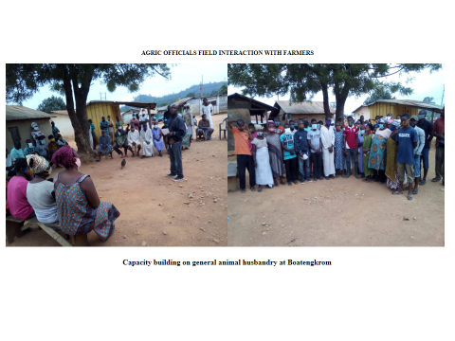

IN SERVICE TRAINING ON BREEDING IMPROVEMENT

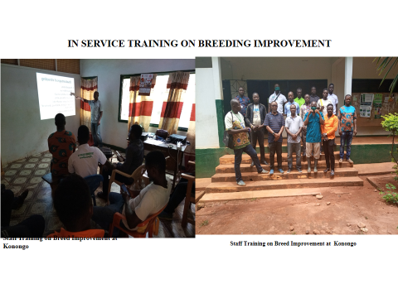

DEMONSTRATION OF GREENFERT
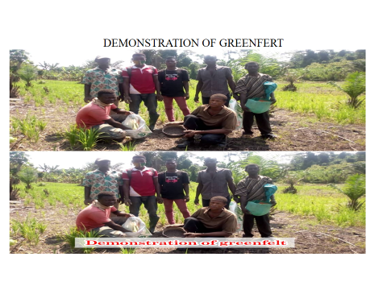

MARKET CENTER

There are six (6) market centres across the municipality. The most vibrant of these markets is the Konongo market with Tuesday as it main market day and Friday as a supportive market day. Due to the nodal position of the market, traders from the neighbouring districts and beyond patronise.
The table below depicts various market centres in the Municipality with their respective locations.
NB. The table is arranged in order of it vibrancy with the most vibrant market on top.
Table 1 Various Market centers in the Municipality with their respective locations.
 | NAME | LOCATION | MARKET DAYS
1 | Konongo Market | Konongo | Tuesdays
2 | Odumasi Market | Odumasi | Thursdays
3 | Dwease Market | Dwease | Wednesday
4 | Praaso Market | Praaso | Tuesdays
5 | Patriensa Market | Patriensa | Daily market
6 | Odumasi Zongo Market | Odumasi | Daily
The weekly market at Agogo in the district is a major marketing center where commodities are sold and exported. The district has two market days Tuesday and Fridays.

- ROAD NETWORK
The Municipality is located along the Accra-Kumasi highway and currently has about 16.5km of asphalted Class I roads, 27km of Class II, and about 134km of Class III. Most of the communities are linked by a good road network. However, these road networks are feeder roads with poor road surface making it unmotorable especially during the rainy season.
The poor quality of roads directly corresponds to a high transport costs particularly with the transport of agricultural produce from the rural areas.

- EDUCATION
The Directorate seeks to provide quality education to children within the school going age in the municipality irrespective of gender, language and Geographical location. To achieve this vision, the office has been collaborating with SMCs parents Development Partners, NGO, Traditional Authorities, Religious organizations, Financial Institutions and above all the Municipal Assembly.
The municipality has both basic and secondary schools. In all there are 250 schools in the municipality. Breakdown are as follows: Eighty-Nine (89) Pre-Schools, Eighty-Nine (89) Primary Schools, Sixty-Six (66)Junior High Schools, Five (5) Senior High Schools and One (1) Technical/vocational school.
The Directorate moved up from 99th position on the National BECE League table to 86th Position this year. The BECE Pass rate similarly experience remarkable improvement. Out of the 66 public and private JHS which sat for the BECE 24 had 100% pass rate with 16 students obtaining distinction. Unlike the previous year where only 4 students obtained distinction. The Gross Enrolment Rate (GER) increased from 85% the previous year to 90%. Gross Admission Rate (GAR) increased from 80% to 88%. Gender parity Index at the Primary Level improved marginally from 0.98 to 0.99. Gender Parity Index at the JHS equally increased from 0.94 to 0.97.
New Curriculum
- Digital Literacy
- Critical Thinking
- Leadership Skills
Major Activities
- Distribution Of PPES
- Tracking Of Safety Protocols
- Mock For BECE Candidates
- CSSPS Orientation
- School Monitoring
- Supervision 2020 BECE

Challenges
- Teenage Pregnancy
- 75% Of SMCS Are Inactive
- Truancy
- Large Class Size
- Inadequate Teacher Accommodation in Rural Communities.

Way Forward
- More Class Rooms
- By- Laws To Stem Teenage Pregnancy
- Re-Activation Of SMCS In Schools
- Teachers’ Quarters Should Be Extended To Communities Like Beposo/Boatengkrom, Atunsu, Ohenenkwanta & Kwakorkor.

PUBLIC SCHOOLS |  |  |  |  |  |  | PRIVATE SCHOOLS
S/N | LEVEL | NO. OF SCHOOLS | ENROLMENT |  |  |  | S/N | LEVEL | NO. OF SCHOOLS | ENROLMENT
S/N | LEVEL | NO. OF SCHOOLS | BOYS | GIRLS | TOTAL |  | S/N | LEVEL | NO. OF SCHOOLS | BOYS | GIRLS | TOTAL
1 | KG | 51 | 1886 | 1860 | 3746 |  | 1 | KG | 50 | 1320 | 1304 | 2624
2 | PRIMARY | 51 | 5250 | 5118 | 10368 |  | 2 | PRIMARY | 49 | 2725 | 2857 | 5582
3 | JHS | 43 | 2377 | 2343 | 4720 |  | 3 | JHS | 28 | 780 | 826 | 1606
4 | SHS | 3 | 2892 | 3514 | 6406 |  | 4 | SHS | 2 | 202 | 321 | 523
 | TOTAL | 148 | 12405 | 12835 | 25240 |  |  | TOTAL | 129 | 5027 | 5308 | 10335

PRIVATE SCHOOLS
S/N | LEVEL | NO. OF SCHOOLS | ENROLMENT
S/N | LEVEL | NO. OF SCHOOLS | BOYS | GIRLS | TOTAL
1 | KG | 50 | 1320 | 1304 | 2624
2 | PRIMARY | 49 | 2725 | 2857 | 5582
3 | JHS | 28 | 780 | 826 | 1606
4 | SHS | 2 | 202 | 321 | 523
 | TOTAL | 129 | 5027 | 5308 | 10335

 |  |  | TEACHING STAFF
S/N
S/N | LEVEL | TRAINED TEACHERS |  |  | UNTRAINED TEACHERS
S/N | LEVEL | M | F | T | M | F | T
1 | KG | 11 | 146 | 157 | 0 | 1 | 1
2 | PRIMARY | 167 | 271 | 438 | 2 | 1 | 3
3 | JHS | 244 | 178 | 422 | 2 | 0 | 2
4 | SHS | 196 | 70 | 266 | 23 | 2 | 25
 | TOTAL | 618 | 665 | 1283 | 27 | 4 | 31

% OF TEACHERS TRAINED |  |  | PTR | PTTR
M | F | T | PTR | PTTR
100 | 99.3 | 99.4 | 24 | 24
98.8 | 99.6 | 99.2 | 24 | 24
99.2 | 100 | 99.5 | 11 | 11
89.5 | 97.2 | 91.4 | 22 | 24

S/N
S/N | LEVEL | TRAINED TEACHERS |  |  | UNTRAINED TEACHERS |  |  | GRAND TOTAL |  |  | % OF TEACHERS TRAINED
S/N | LEVEL | M | F | T | M | F | T | M | F | T | M | F | T
1 | KG | 4 | 7 | 11 | 14 | 81 | 95 | 18 | 88 | 106 | 22.2 | 8 | 10.4
2 | PRIMARY | 22 | 7 | 29 | 161 | 79 | 240 | 183 | 86 | 269 | 12 | 8.1 | 10.8
3 | JHS | 18 | 3 | 21 | 104 | 6 | 335 | 122 | 9 | 131 | 14.8 | 33.3 | 16
4 | SHS | 10 | 3 | 13 | 0 | 0 | 0 | 10 | 3 | 13 | 100 | 100 | 100
 | TOTAL | 54 | 20 | 74 | 279 | 166 | 445 | 333 | 186 | 519

HEALTH
The Municipality has only one public hospital located in the Municipal capital, Konongo – Odumasi. This facility serves residents within the Municipality and beyond. There are also three privately-owned hospitals in Konongo to assist in providing health care services. There are Four health Centres in the municipality located in Dwease, Odumase, Patriensa and Praaso, to attend to minor cases and illnesses. Services provided at such facilities include, out-patient, ante-natal, in-patient and dispensary. Furthermore, the municipality has Five (5) Community-Based Health Planning Services (CHPS) compounds. Located at Kramokrom, Boatengkrom, Kyekyewere, Kyekyebiase and Obenimase.
According to the Kramokrom Health Directorate, the ten (10) top reported diseases in the Municipal are as follows; malaria, acute eye infection, upper respiratory tract infection, acute urinary tract infection, gynecological condition, peptic ulcer disease, skin disease, pregnancy related conditions, lower abdominal pain and Road traffic accidents cases.
To reduce the above diseases, the following interventions has been put in place:
- Offering more scholarships to increase doctor nurse population ratio
- Implementation of rollback malaria polices
- Facilitate accreditation of health facilities to national health insurance scheme
- Increasing access to health care through establishment of CHPS compound
- Sensitization on health related issues
- Partnership with NGO to deal with health relative issues
Sub district | Hosp | H/C | Clinics | CHPS Comp. | Total
Konongo | 2 | 0 | 3 | 0 | 5
Dwease-Praaso | 0 | 2 | 0 | 2 | 4
Patriensa | 0 | 1 | 0 | 2 | 3
Odumase | 0 | 1 | 1 | 1 | 2
Total | 2 | 4 | 4 | 5 | 15

Municipal Background Information on Health
Population | 89,261
Population under 0-11 months 4% | 3,570
Expected pregnancy 4% | 3,570
Vitamin A (6-59mnths) 14.5% | 12,943
WIFA 24% | 21,423
Number of sub-municipals | 4
No of CHPS Zones | 25

Sub district | Hosp | H/C | Clinics | CHPS Comp. | Total
Konongo | 2 | 0 | 3 | 0 | 5
Dwease-Praaso | 0 | 2 | 0 | 2 | 4
Patriensa | 0 | 1 | 0 | 2 | 3
Odumase | 0 | 1 | 1 | 1 | 2
Total | 2 | 4 | 4 | 5 | 15
Priorities for 2020
- Improving data management
  - on job training and coaching for staff on DHIMS
  - on job training for staff on report capturing
  - Strengthen data validation teams (Municipal and facilities)
  - Ensure timely & completeness reporting on DHIMS
- Strengthen collaboration with private facilities
- Carry out a successful half year performance review/ narrative report
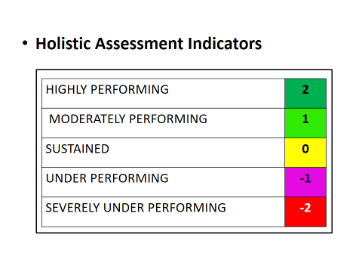
Trend by OPD Sub Municipal
FACILITIES | HALF YEARS |  |  | Performance Change | % Increase/ decease
FACILITIES | 2018 | 2019 | 2020 | Performance Change
Dwease-Praaso | 6239 | 5714 | 5846 | 132 | 2
Konongo | 52366 | 31345 | 25623 | -5722 | -18
Odumase | 1064 | 1623 | 1615 | -8 | 0
Patriensa | 2542 | 2290 | 2998 | 708 | 31
Municipal | 62211 | 40972 | 36082 | -4890 | -12

Trend in OPD Attendance Facilities
FACILITIES | HALF YEARS |  |  | Performance Change | % Increas/Decrease
FACILITIES | 2018 | 2019 | 2020 | Performance Change | % Increas/Decrease
Boatengkrom CHPS |  | 191 | 528 | 337 | 176
Dwease Health Centre | 3419 | 2218 | 2484 | 266 | 12
Kramokrom CHPS | 64 | 326 | 531 | 205 | 63
Praaso Health Centre | 2756 | 2979 | 2303 | -676 | -23
First Klass Hospital | 26061 | 7311 | 0 | -7311 | -100
Konongo - Odumasi Government Hospital | 22191 | 20812 | 22759 | 1947 | 9
Lifeland Clinic | 2655 | 1954 | 1306 | -648 | -33
Multi-Tech Clinic | 410 | 806 | 724 | -82 | -10
Patience Clinic | 1049 | 462 | 834 | 372 | 81
KOSS Clinic | 1064 | 1518 | 458 | -1060 | -70
Odumase Apebuoso CHPS |  | 105 | 1157 | 1052 | 1002
Kyekyebiase CHPS |  | 161 | 552 | 391 | 243
Obenimase CHPS | 788 | 593 | 430 | -163 | -27
Patriensa Ahenbronum Health Centre | 1754 | 1536 | 2016 | 480 | 31
Konongo Extension(Amefa)/kyekyewere CHPS | 0 | 0 | 0 | 0 | 0
MUNICIPAL TOTAL | 62211 | 40972 | 36082 | -4890 | -12

Activities Carried Out
- Active case findings for priority diseases including Covid -19.
- Public education on Meningitis
- EPI data validation at health facilities
- Conducted EPI Training and mass campaign of Inactivated Polio vaccine (IPV).

Challenges
- Inadequate office space
- Faulty laptop/ desktop for data management
- Non – submission of hard copies of reports by facilities
- Late submission of monthly reports
- Inactive data validation teams
- Non submission of data validation reports
- None submission of some reports on dhims ( First Klass)
- None authorization of reports before submission
- Low commitment to employ data officers especially private facilities to assist with data entries
- Inadequate funding
- Late submission of weekly IDSR reports

Way Forward

- To lobby for PC for the HI unit
- To lobby for office space
- To conduct supportive visits to facilities
- To give monthly feedbacks on DHIMS
- Hoping for a new office
- Encourage facilities to intensify activities aim at achieving EPI targets
- Mop up
- Home visits
- Special CWC sessions
- Improve upon screening at various units of the facilities for Diseases of Public Health Importance and concern (TB, HIV, Covid 19 etc)
- Intensify case search and reporting of Neglected Tropical Diseases (Yaws, Leprosy, Oncho, BU etc).

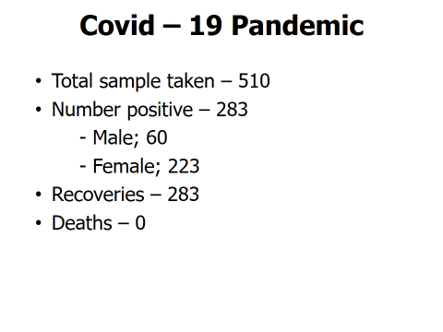

NATIONAL HEALTH INSURANCE SCHEME – ASANTE AKIM CENTRAL MUNICIPAL
Credentialed Providers
 | FACILITY NAME | FACILITY TYPE | OWNERSHIP | LOCATION
1 | Agogo Presbyterian Hospital | Hospital | CHAG | Agogo
2 | Konongo Odumasi Govt Hospital | Hospital | Public | Konongo
3 | First Klass Hospital | Hospital | Public | Konongo
4 | Dwease Health Centre | Health Centre | Public | Dwease
5 | Praaso Health Centre | Health Centre | Public | Praaso
6 | Boatengkrom CHPS | CHPS | Public | Boatengkrom
7 | Kramokrom CHPS | CHPS | Public | Kramokrom
8 | Lifeland Clinic | Clinic | Private | Konongo
9 | Stellex Pharmacy | Pharmacy | Private | Konongo

10 | Multitech Clinic | Clinic | Private | Konongo
11 | Hi-Tech Diagnostic Centre | Diagnostic Centre | Private | Konongo
12 | Odumasi Health Centre | Health Centre | Public | Odumasi
13 | Oheneba Pharmacy | Pharmacy | Private | Konongo
14 | Patriensa Health Centre | Health Centre | Public | Patriensa
15 | Kyekyebiase CHPS | CHPS | Public | Kyekyebiase
16 | Obenemase CHPS | CHPS | Public | Obenemase
17 | Domeabra CHPS | CHPS | Public | Domeabra
18 | Pekyerekye CHPS | CHPS | Public | Pekyerekye

19 | Tanoah Baptist Medical Centre | Clinic | Mission | Opuniase
20 | Amantena CHPS | CHPS | Public | Amantena
21 | Nyinamponase Health Centre | Health Centre | Public | Nyinamponase
22 | Akutuase CHPS | CHPS | Public | Akutuase
23 | Wioso CHPS | CHPS | Public | Wioso
24 | Kings&Royal Pharmacy | Pharmacy | Private | Agogo
25 | Agogo Zongo CHPS | CHPS | Public | Agogo
26 | Pataban CHPS | CHPS | Public | Pataban
27 | Ananekrom Health Centre | CHPS | Public | Ananekrom
28 | Juansa Health Centre | Health Centre | Public | Juansa

Credential Providers (Summary)
FACILITY TYPE | ASANTE AKIM CENTRAL | ASANTE AKIM NORTH | TOTAL
Hospitals | 2 | 1 | 3
Clinics | 2 | 1 | 3
Pharmacy | 2 | 1 | 3
Diagnostic Centre | 1 | 0 | 1
Health Centre | 4 | 2 | 6
CHPS | 4 | 8 | 12
TOTAL | 15 | 13 | 28

Claims Payment
PERIOD OF PAYMENT | AMOUNT | RELATED MONTHS
3RD QTR of 2020 | 866,624.21 | January – March, 2020
2ND QTR of 2020 | 2,080,732.58 | August – December, 2019
3RD QTR of 2019 | 1,482,264.80 | July – December, 2018 and January, 2019

Challenges
- Inadequate logistics to fully operate all our sub-offices
- Non-availability of the official vehicle
- Frequent Applications Downtimes
- Inadequate Staff
- Inadequate funds for office operations and delay in transferring the fund
- Delay by the Ministry of Finance to release funds for the payment of claims
- Illegal charges levied on our members at provider site
Way Forward
- Mobile Renewal
- E-Receipting
- E-Claims

SUPPORT TO PERSONS WITH DISABILITY
During the 3rd quarter 2020, the department procured and distributed items for forty-nine (49) PWDs to empower them economically. Items bought for economic empowerment are as follows, Deep Freezers, sewing machines shoe making tools, charcoal, phone repairs tools, hair dressing tools mobile scratch cards etc.
BREAKDOWN OF BENEFICIARIES.
NATURE OF DISABILITY | MALE | FEMALE | TOTAL
PHYSICALLY CHALLENGED | 15 | 21 | 36
DEAF | - | 1 | 1
BLIND | 4 | 5 | 9
OTHER DISABILITIES | - | 3 | 3
TOTAL | 19 | 30 | 49

Breakdown of Items
ITEMS PROCURED | NUMBER OF BENEFICIARIES
Fridge / Deep Freezer | 12
Hair Dressing Equipment & Materials | 2
Auto Electrician | 1
Sewing Machine | 6
Shoe Making Tools & Equipment | 1
Batik Making | 1
Vegetables | 1
Sheep Farming | 1
Piggery | 1
Fufu Pounding Machine | 1
Soap Business | 1
Charcoal | 16
Phone Repairs Tools | 1
Bags Of Maize | 1
Bags Of Salt | 1
Mobile Cards | 2
TOTAL | 49

WATER
The main source of water for domestic and commercial uses is borehole and pipe borne water. Majority of the rural household depends on borehole water for drinking, cooking and other household chores
According to the 2010 PHC District Analytical Report, about forty-seven percent (47%) of the rural household depends on borehole water for drinking, cooking and other household chores. Other sources include rain water, dug well, rivers, streams etc.

SANITATION

According to the 2010 Population and Housing Census, the toilet facility mostly used by household in the municipality is public toilet, (KVIP and Pit). This constitutes 34.2% of the toilet facilities in their homes, KVIP and Water Closets constitute 25.7%, 20.7% and 11.2% of the toilet facilities in the municipality respectively. Open defecation and others also constitutes 8.2%

Also, waste management is another sanitation issue confronting the municipality. The commonest methods of waste disposal are open space and public containers. Whereas open space is predominantly practiced in the rural areas, public containers is practiced in the urban areas. Other forms of waste disposal include open burning, indiscriminate dumping and refuse pit.

Solid Waste

Solid Waste Disposal
Table 8.15 presents different methods of solid waste disposal by households. The commonest method of disposal of solid waste is dumping in a public dump (open space). The proportion for this method of solid waste disposal is 40.1 percent. This is followed by dumping into containers (34.8%). Burning is used by 10.0 percent. It is uncommon for solid waste to be collected from households as only 4.1 percent of the households in the Municipality use this service.
In the urban localities, the commonest method of disposal of solid waste is dumping in public containers (46.2%). This is followed by dumping in public dumping sites (31.4%). The least proportion goes for household that dump indiscriminately (3.1%).
In rural localities, more than half (60.4%) of households dump solid waste in public dumping sites. Those that burn solid waste constitute 12.0 percent. As high as 11.7 percent of households dump solid waste indiscriminately.
Solid waste management in the Municipality is challenging and this is mostly caused by garbage from agricultural farm produce.
The following measures are being put in place to solve his issues
- Feasibility studies are under way for recycling of the waste
- Acquiring landfill site,
- Procuring additional skip containers.

Table 1.17: Method of Solid Waste Disposal by Households
 | Municipality
 | Total
 | Number | Percent
Total | 16,919 | 100.0
Collected | 696 | 4.1
Burned by household | 1,690 | 10.0
Public dump (container) | 5,889 | 34.8
Public dump (open space) | 6,779 | 40.1
Dumped indiscriminately | 964 | 5.7
Buried by household | 766 | 4.5
Other | 135 | 0.8
Source: Ghana Statistical Service, 2010 Population and Housing Census.

Liquid Waste Disposal
The various methods by which liquid waste is disposed by households in the Municipality is presented in table 8.16. The majority of households (36.6%) in the Municipality dispose liquid waste by throwing onto the street/outside. This is closely followed by throwing onto compound (35.7%). Throwing into gutter has a proportion of 17.3 percent and disposal through drainage into a pit (soak away) has the least proportion (1.3%).
In urban localities, the majority (36.2%) of households dispose liquid waste by throwing onto the street/outside. Throwing onto compound is used by 31.6 percent of households and a little over twenty percent (21.2%) of households dispose liquid by throwing into gutter. Disposal through drainage into a pit (soak away) has the least proportion (1.0%).
For the rural localities, 45.4 percent of households throw liquid waste onto compound. This is higher than the proportion for urban localities (31.6%). About thirty eight percent (37.5%) of households in rural localities throw liquid waste onto the street/outside. This is more than the urban proportion (36.2%) albeit the small margin. Disposing liquid waste through the sewerage system is not common in the rural localities at all, as it has a proportion less than one percent (0.5%).

Table 1.18: Method of Liquid Waste Disposal by Households
 | Municipality
 | Total
 | Number | Percent
Total | 16,919 | 100.0
Through the sewerage system | 262 | 1.5
Through drainage system into a gutter | 1,250 | 7.4
Through drainage into a pit (soak away) | 225 | 1.3
Thrown onto the street/outside | 6,187 | 36.6
Thrown into gutter | 2,925 | 17.3
Thrown onto compound | 6,042 | 35.7
Other | 28 | 0.2
Source: Ghana Statistical Service, 2010 Population and Housing Census.

Liquid Waste
The Municipal has acquired a land fill site to solve it liquid waste. It is the view of management to facilitate the building of an engineered final disposal site in the medium term.
Sanitation By-Laws
The district has gazetted it sanitation bye-laws and seek to ensure strict enforcement to deal with offenders.

ENVIRONMENT
  - The environmental situation is challenging just as in other districts.
  - The natural environment consists of water, soils, atmosphere, flora and fauna with energy being provided by the sun.
  - The natural environment of the Municipal has been negatively affected by human activities.
  - These activities include overgrazing, slash and burn method of farming, bush fires, over logging, sand winning and the use of wood and charcoal as energy source.

ENERGY
Energy plays a significant role in households’ day-to-day activities. The main source of energy in the municipality is electricity which is taped from the national grid. It is used for powering domestic appliances for cooking, storage and entertainment, lighting systems among others. According to the 2010 Population and Housing Census (71.5%) have access to electricity in their homes, while 10.4% depend on kerosene lamps. Furthermore, 16.7% of the residents rely on battery-powered flashlights and touches with 0.4% depending on diesel powered generators.
Despite several interventions by government and non-governmental organizations to protect our forests and reduce pollution, majority of residents in the Asante Akim Central Municipality, continue to use firewood. According to 2010 Population and Housing Census, 38.7% of the residents use firewood for cooking while 36.1% use charcoal. Nevertheless, an appreciable number of residents rely on efficient energy sources such as gas (15.6%), electricity (0.3%) and kerosene (0.4%).

Figure 1.9.: Main source of Lighting of Dwelling Unit by type of locality

Source: Ghana Statistical Service, 2010 Population and Housing Census

- Transportation
In the transport sector, the Assemblies objective under the GSGDA II was to Create and sustain an efficient and effective transport system that meets user needs and maximising access to the whole municipality to facilitate the carriage of cargo and haulage of agriculture produce to the city centres and market areas. Some of the measures implemented were include Rehabilitation of streets/drains and construction of storm drains.

- Trade and commerce
Trade and commerce in the municipality is very brisk due to its nodal location. The municipal capital serves as the commercial hub of the municipality.
There are a number of markets in the municipality. These markets provide avenues for transactions in the buying and selling of both agricultural and industrial goods. They also contribute significantly to the Assembly’s Internally Generated Fund (IGF).
- . Mining and quarrying
The Municipality’s gold deposits have made it one of the notable gold mining areas in the region. Large scale gold mining is done by one company with its main mining site at Konongo with another site at the Obenimase area. Apart from the company, there are a number of small scale miners in the municipality. The Dwease–Praaso area rich in extensive granite has potential for large scale quarrying

KEY ACHIEVEMENTS IN 2020
PROGRAMME /PROJECTS
- The Education Directorate moved up from 99th position on the National BECE League table to 86th Position this year (2020 academic year).
- Constructed 1 no solar- powered mechanized borehole at Patriensa
- We have constructed 2 no solar- powered mechanized borehole at Konongo- Ahenbronum and Abosomtweagya
- Constructed 5 unit classroom block with ancillary facilities at Kyekyewere
- Constructed 3 unit classroom block with ancillary facilities at Wesley High
- Constructed 3 unit classroom block with ancillary facilities at Atunsu
- Constructed 3 unit classroom block with ancillary facilities at Adumkrom
- Constructed 6unit classroom block with ancillary facilities at Konongo Presby
- Constructed 6unit classroom block with ancillary facilities at Abosomtweagya
- Constructed 3 storey 12 unit classroom block with ancillary facilities at Konongo Odumasi SHS
- Refurbished and upgraded electronic library at Konongo Odumasi SHS
- Constructed 400 bed dormitory at Konongo Odumasi SHS
- Distributed of over 65,000 Cocoa seedlings and over 30,000 oil palm seedlings to farmers
- Provided start up kits and items to PWDs and Timely distribution of economic empowerment items for beneficiaries of the disability fund,
- Provided over 350 dual and mono desks furniture to selected schools
- Provided start-up kits for SMEs

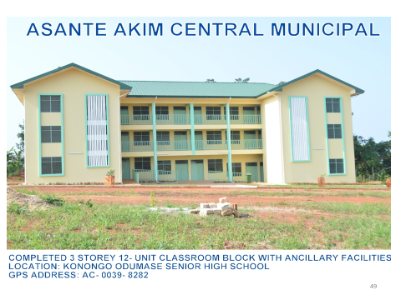

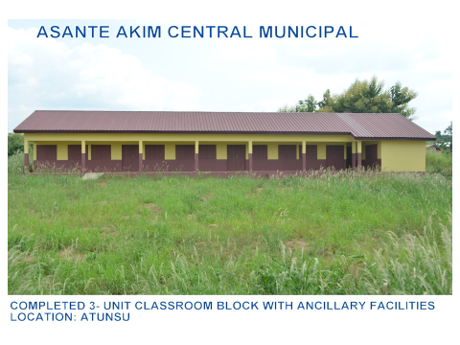
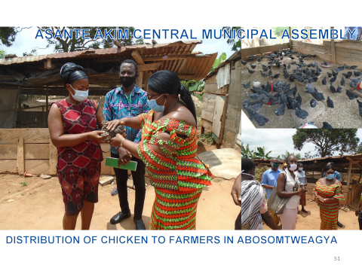
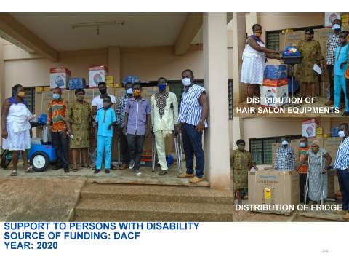
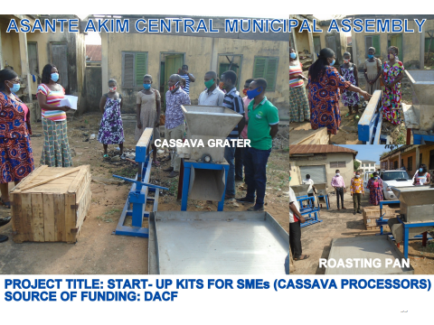

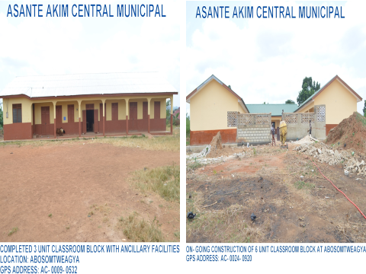
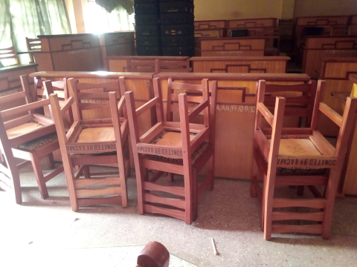
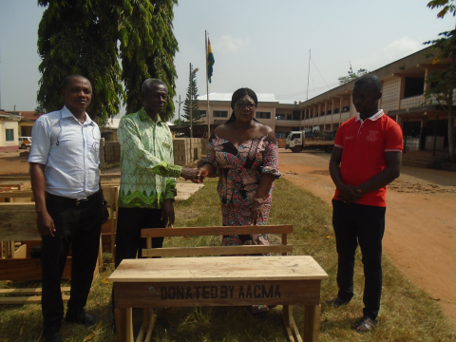
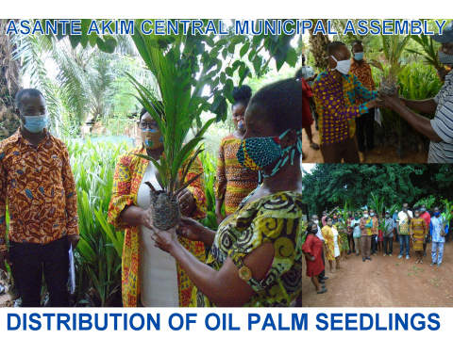
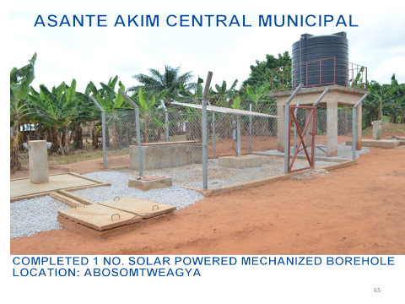
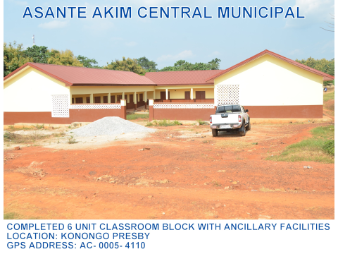
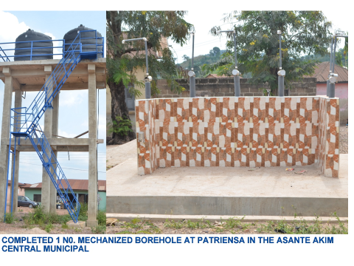
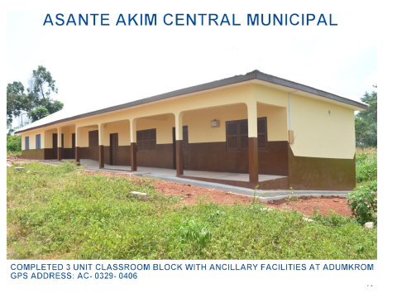
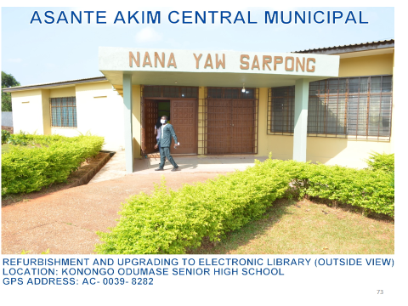
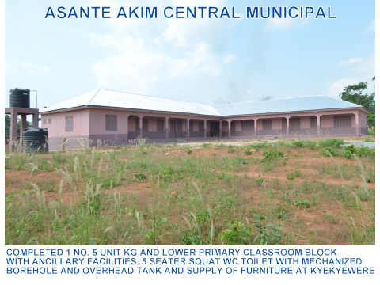
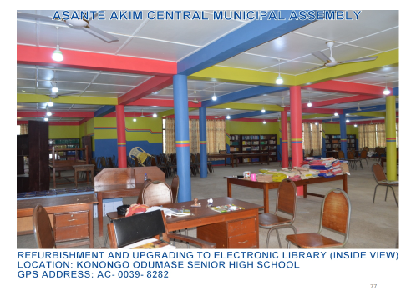
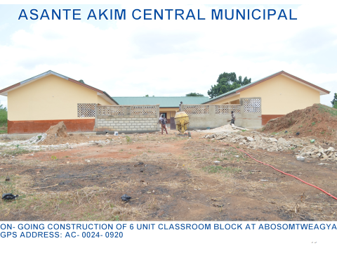
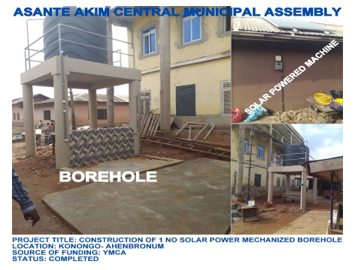
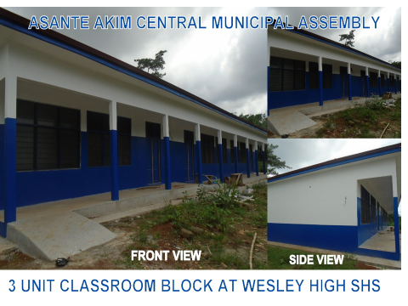
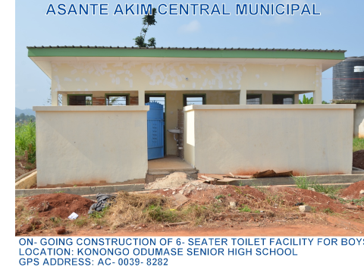
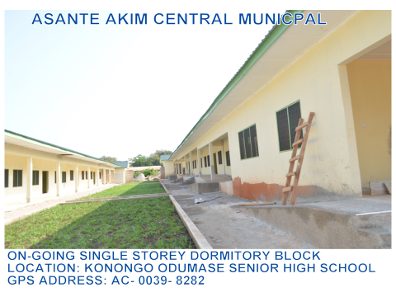
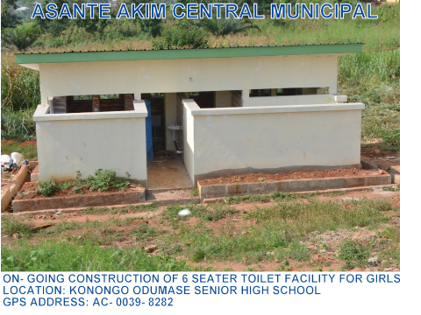

REVENUE AND EXPENDITURE PERFORMANCE

REVENUE
Table 3: Revenue Performance - IGF
REVENUE PERFORMANCE- IGF ONLY
ITEM | 2018 |  |  | 2019 |  | 2020 |  | % at August, 2020
 | Budget | Actual |  | Budget | Actual | Budget | Actual as at August
Basic Rate | 3,000.00 | 1,250.00 |  | 5,000.00 | 891.00 | 5,000.00 | 439 | 0.06
Property Rate | 273,475.21 | 216,534.76 |  | 270,905.21 | 179,602.53 | 270,905.21 | 186,849.11 | 26.96
Fees | 459,120.16 | 186,338.93 |  | 570,080.00 | 343,638.00 | 567,500.00 | 188,234.00 | 27.16
Fines | 116.400.00 | 249,323.66 |  | 26,440.00 | 15,390.00 | 29,440.00 | 5,387.00 | 0.78
Licenses | 252,000.00 | 18,255.00 |  | 303,835.00 | 225,430.69 | 308,675.00 | 140,131.50 | 20.22
Rent | 76,190.00 | 18,255.00 |  | 77,870.00 | 130,544.00 | 77,870.00 | 49,784.00 | 7.18
Stool Lands | 25,000 | 15,000.00 |  | 15,000.00 | 20,000.00 | 20,000.00 | 0 | -
Miscellaneous | 3,000.00 | 4,994.49 |  | 3,000.00 | 300.00 | 1,000.00 | 250 | 0.04
TOTAL | 1,275,860.21 | 863,659.84 |  | 1,420,480.21 | 1,087,566.22 | 1,442,990.21 | 693,008.61 | 100.00

.
Table 4: Revenue Performance - All Sources
REVENUE PERFORMANCE- ALL REVENUE SOURCES
ITEM | 2018 |  | 2019 |  | 2020 |  | % at August, 2020
 | Budget | Actual | Budget | Actual | Budget | Actual as at August, 2020
IGF | 1,275,860.21 | 863,659.84 | 1,420,480.21 | 1,087,566.22 | 1,442,990.21 | 693,008.61 | 48.03
Compensation Transfer | 2,459,864.72 | 1,821,918.84 | 3,267,450.00 | 2,265,413.28 | 2,795,893.53 | 1,510,275.52 | 54.02
Goods and Services transfer | 64,043.51 | 158,042.37 | 110,047.20 | 13,349.83 | 119,856.66 | 93,545.90 | 78.05
DACF | 3,574,578.42 | 2,123,905.05 | 4,653,368.40 | 2,375,537.14 | 5,052,741.93 | 1,629,942.30 | 32.26
DDF | 480,777.00 | 422,633.00 | 976,219.00 | 776,808.27 | 701,499.34 | 391,516.84 | 55.81
Other donor (mag) | 75,000.00 |  | 172,948.68 | 186,250.00 | 270,575.86 | 199,698.57 | 73.81
Total | 8,202,193.65 | 5,390,159.10 | 10,600,513.49 | 6,704,924.74 | 10,418,172,91 | 4,424,441.84 | 42.47

EXPENDITURE
Table 5: Expenditure Performance - All Sources
EXPENDITURE PERFORMANCE (ALL DEPARTMENTS) – ALL SOURCES
Expenditure | 2018 |  | 2019 |  | 2020
 | Budget | Actual | Budget | Actual | Budget | Actual as at August | %  August 2020
Compensation | 3,735,724.93 | 2,685,578.68 | 4,687,930.21 | 3,352,979.50 | 4,238,883.74 | 2,203,284.13 | 51
Goods and Services | 2,723,037.83 | 1,546,878.99 | 3,968,548.87 | 2,176,549.90 | 3,524,765.27 | 1,344,172.42 | 38.14
Assets | 1,743,430.89 | 1,157,701.43 | 1,944,034.41 | 1,175,395.34 | 2,654,523.90 | 876,985.29 | 33.04
Total | 8,202,193.65 | 5,390,159.10 | 10,600,513.49 | 6,704,924.74 | 10,418,172.91 | 4,424,441.84

EXPENDITURE
Table 5: EXPENDITURE PERFORMANCE (ALL DEPARTMENTS) IGF ONLY
EXPENDITURE PERFORMANCE (ALL DEPARTMENTS) IGF ONLY

Expenditure | 2018 |  | 2019 |  | 2020
 | Budget | Actual | Budget | Actual | Budget | Actual as at August | %  August 2020
Compensation | 3,735,724.93 | 2,685,578.68 | 4,687,930.21 | 3,352,979.50 | 4,238,883.74 | 2,203,284.13 | 51.98
Goods and Services | 2,723,037.83 | 1,546,878.99 | 3,968,548.87 | 2,176,549.90 | 3,524,765.27 | 1,344,172.42 | 38.14
Assets | 1,743,430.89 | 1,157,701.43 | 1,944,034.41 | 1,175,395.34 | 2,654,523.90 | 876,985.29 | 33.04
Total | 8,202,193.65 | 5,390,159.10 | 10,600,513.49 | 6,704,924.74 | 10,418,172.91 | 4,424,441.84 | 42.47

ASANTE AKIM CENTRAL MUNICIAPL ASSEMBLY’S ADOPTED POLICY OBJECTIVES

Mobilize additional financial resources for development from multiple sources

Ensure free, equitable and quality education for all by 2030

Achieve access to adequate and equitable Sanitation and hygiene

Achieve universal health coverage, access to quality health-care services.

Improve production efficiency and yield.

Enhance inclusive urbanization & capacity for settlement planning

Implement appropriate Social Protection Sys. & measures

Facilitate sustained and resilient infrastructure dev.

Ensure all learners acquire knowledge & skills, to promote sustainable dev.

Include settlements implementation, inter climate change & disaster risk redemption.

Improve efficiency & effectiveness of road transport infrastructure & service.

Deepen political and administrative decentralization.

POLICY OUTCOME INDICATORS AND TARGETS
Table 7: Policy Outcome Indicators and Targets
Outcome Indicator Description | Unit of Measurement | Baseline |  | Actual Performance
Outcome Indicator Description | Unit of Measurement | Year 2019 | Value | Target For the Year 2020 | Actuals as Aug.
Increase in the number of educational infrastructure | Number of classrooms | 630 | 624 | 628 | 626
Increase in the number of educational infrastructure | Number of classroom blocks | 250 | 245 | 252 | 250
Increase in the number of educational infrastructure | Number of Desk Provided | 350 | 350 | 400 | 350
Increase access to health infrastructure | Number of health facilities provided | 6 | 4 | 6 | 5
Upgrade market infrastructure | Number of market facilities upgraded | 2 | 1 | 2 | 1
Improvement in business development skills | Number of business/skills development trainings organised | 20 | 10 | 20 | 15
Economic empowerment of PWDs | No of PWDs supported | 150 | 145 | 150 | 48
Outcome Indicator Description | Unit of Measurement | Baseline |  | Actual Performance
Outcome Indicator Description | Unit of Measurement | Year 2019 | Value | Target For the Year 2020 | Actuals as Aug.
Child right and family welfare promoted | No of cases resolved | 150 | 134 | 152 | 100
Alleviate extreme poverty | Number of persons supported | 350 | 275 | 500 | 402
Increase stakeholders participation | Number of stakeholders meetings organised | 4 | 4 | 4 | 2
Build capacity of land owners and chiefs on settlement planning | Number of development application processed | 130 | 95 | 140 | 125
National Digital addressing or AACMA | Number of street and properties named and numbered | 50 | 40 | 50 | 0

REVENUE MOBILIZATION STRATEGIES FOR KEY REVENUE SOURCES
REVENUE SOURCE | KEY STRATEGIES
- RATES (Basic Rates/Property Rates) | -Sensitize the public on the need to pay rate  -Update data on all properties within the municipality  -Undertake property valuation and revaluation exercise
- LANDS | -Ensure that land developers who submit their building permit are processed within one month  -Sensitize the public on the need to register their plots and acquire permit before building  -Prosecute land developers who build without permits to serve as deterrent to others
- LICENSES | -Sensitize the private business operators to register their business and renew the licenses very year
4. RENT | -Engage and enforce that occupants pay their rent  -Regular maintenance of buildings to motivate tenants to pay their rents
5.FEES AND FINES | -Task force to monitor and assess revenue on market day  -Prosecute defaulters to take fines when applicable  -Regular monitoring of fees such as market/lorry park tolls and burial fees  - Regular maintenance of Assembly facilities
6.GENERAL STRATEGIES | -Use computer software to generate bills and demand notice/point of sale device  -Ceding parts of the revenue item to the zonal council  -Training for revenue collectors  - Motivating hardworking collectors and sanction recalcitrant collectors  - Develop and periodically review a robust Revenue improvement Action Plan (RIAP) to deal with tax leakages

PART B: BUDGET PROGRAMME/SUB-PROGRAMME SUMMARY

PROGRAMME 1: MANAGEMENT AND ADMINISTRATION

- Budget Programme Objectives
- To provide support services, effective and efficient general administration and organization of the Municipal Assembly.
- To insure sound financial management of the Assembly's resources.
- To coordinate the development planning and budgeting functions of the Assembly.
- To provide human resource planning and development of the Municipal Assembly.

- Budget Programme Description
The program seeks to perform the core functions of ensuring good governance and balanced development of the Municipal Assembly through the formulation and implementation of policies, planning, coordination, monitoring and evaluation in the area of local governance.

The Program is being implemented and delivered through the offices of the Central Administration and Finance Departments. The various units involved in the delivery of the program include; General Administration Unit, Budget Unit, Planning Unit, Accounts Office, Procurement Unit, Human Resource, Internal Audit and Records Unit.

A total staff strength of Fourty (40) is involved in the delivery of the programme. They include Administrators, Budget Analysts, Accountants, Planning Officers, Revenue Officers, and other support staff (i.e. Executive officers, and drivers). The Program is being funded through the Assembly’s Composite Budget with Internally Generated Fund (IGF) and Government of Ghana transfer such as the District Assemblies’ Common Fund and District Development Facility.
BUDGET SUB-PROGRAMME SUMMARY

PROGRAMME1: Management and Administration

SUB-PROGRAMME 1.1 General Administration

- Budget Sub-Programme Objective
- To provide administrative support and ensure effective coordination of the activities of the various departments and quasi institutions under the Municipal Assembly.
- To ensure the effective functioning of all the sub-structures to deepen the decentralization process.

- Budget Sub-Programme Description
The General Administration sub-programme looks at the provision of administrative support and effective coordination of the activities of the various departments through the Office of the Municipal Co-ordinating Director. The sub-programme is responsible for all activities and programmes relating to general services, internal controls, procurement/stores, transport, public relation and security.
The core function of the General Administration unit is to facilitate the Assembly’s activities with the various departments, quasi institution, and traditional authorities and also mandated to carry out regular maintenance of the Assembly’s properties. In addition, the Municipal Security Committee (MUSEC) is mandated to initiate and implement programmes and strategies to improve public security in the District.
The Internal Audit Unit is authorized to spearhead the implementation of internal audit control procedures and processes to manage audit risks, detection and prevention of misstatement of facts that could lead to fraud, waste and abuse to the Assembly.
Under the sub-programme the procurement processes of Goods and Services and Assets for the Assembly and the duty of ensuring inventory and stores management is being led by the Procurement/Stores Unit.
The number of staff delivering the sub programme comprises 1 from Procurement Unit, 2 from Internal Audit, Four (4) from Administrative class, One (1) from Stores, Four (4) from Records, Five (5) drivers, Two (2) Radio Operators, One (1) Local Government Inspector, Thirteen (13) Securities and One (1) Secretaries with funding from GoG transfers (DACF, DDF etc.) and the Assembly’s Internally Generated Fund (IGF). Beneficiaries of this sub-program are the departments, Regional Coordinating Council, quasi institutions, traditional authorities, non-governmental organizations, civil society organizations and the general public.
The main challenges this sub programme will encounter are inadequate, delay and untimely release of funds, inadequate office space, and non-decentralization of some key departments.
- Budget Sub-Programme Results Statement
The table indicates the main outputs, its indicators and projections by which the District Assembly measure the performance of this sub-programme. The past data indicates actual performance whilst the projections are the Assembly’s estimate of future performance.
Table 8: Budget Results Statement – Administration

Main Outputs | Output Indicator | Past Years |  | Projections
Main Outputs | Output Indicator | 2017 | 2018 | Budget Year  2019 | Indicative Year  2020 | Indicative Year  2021
Organize quarterly management meetings annually | Number of quarterly meetings held | 4 | 4 | 4 | 4 | 4
Response to public complaints | Number of working days after receipt of complaints | 10 | 10 | 5 | 5 | 5
Annual Performance Report submitted | Annual Report submitted to RCC by | 15th January | 15th January | 15th January | 15th January | 15th January
Compliance with Procurement procedures | Procurement Plan approved by | 30th November | 30th November | 30th November | 30th November | 30th November
Compliance with Procurement procedures | Number of Entity Tender Committee meetings | 4 | 4 | 4 | 4 | 4
Quarterly Internal Audit Report submitted to PM | Number of Audit assignments conducted with reports. | 4 | 4 | 4 | 4 | 4

- Budget Sub-Programme Operations and Projects
The table lists the main Operations and projects to be undertaken by the sub-programme
Table 9: Main Operations and Projects
Operations |  | Projects
Internal Management of Organization |  | Procurement of Office Equipment
Procurement of Office Supplies and Consumables |  | Procurement of Office Furniture and Fitting
Maintenance, Rehab. Refurb. & Upgrading Of Existing Assets
Protocol Services
Administrative and Technical Meetings
Security Management
Citizens Participation in Local Governance

BUDGET SUB-PROGRAMME SUMMARY

PROGRAMME1: Management and Administration

SUB-PROGRAMME 1.2 Finance and Revenue Mobilization

- Budget Sub-Programme Objective
- To insure sound financial management of the Assembly's resources.
- To ensure timely disbursement of funds and submission of financial reports.
- To ensure the mobilization of all available revenues for effective service delivery.

- Budget Sub-Programme Description

This sub-programme provides effective and efficient management of financial resources and timely reporting of the Assembly finances as contained in the Public Financial Management Act, 2016 (Act 921) and Financial Administration Regulation, 2004. It also ensures that financial transactions and controls are consistent with prevailing financial and accounting policies, rules, regulations, and best practices.

The sub-program operations and major services delivered include: undertaking revenue mobilization activities of the Assembly; keep, render and publish statements on Public Accounts; keep receipts and custody of all public and trust monies payable into the Assembly’s Fund; and facilitates the disbursement of legitimate and authorized funds.

The sub-programme is manned by six (6) officers comprising of Accountants, Revenue Officers and Commission collectors with funding from GoG transfers and Internally Generated Fund (IGF).
The beneficiaries’ of this sub- program are the departments, allied institutions and the general public. This sub-programme in delivering its objectives is confronted by inadequate office space for accounts officers, inadequate data on ratable items and inadequate logistics for revenue mobilization and public sensitization.

- Budget Sub-Programme Results Statement
The table indicates the main outputs, its indicators and projections by which the District Assembly measure the performance of this sub-programme. The past data indicates actual performance whilst the projections are the Assembly’s estimate of future performance.
Table 10: Budget Results Statement - Finance and Revenue Mobilization

Main Outputs | Output Indicator | Past Years |  |  |  |  | Projections
Main Outputs | Output Indicator | 2019  Target | 2019  Actual | 2020  Target | 2020  Actual | Budget Year  2021 | Indicative Year  2022 | Indicative Year  2023 | Indicative Year  2023
Annual and Monthly Financial Statement of Accounts submitted. | Annual Statement of Accounts submitted by | 31st March | 31st March | 31st March | 31st March | 31st March | 31st March | 31st March | 31st March
 | Number of monthly Financial Reports submitted | 12 | 12 | 12 | 12 | 12 | 12 | 12 | 12
Achieve average annual growth of IGF by at least 10% | Annual percentage growth | 10% | 10% | 10% | 10% | 10% | 10% | 14% | 15%

- Budget Sub-Programme Operations and Projects
The table lists the main Operations and projects to be undertaken by the sub-programme
Table 11: Main Operations and Projects
Operations |  | Projects
Treasury and Accounting Activities |  | Procurement of office equipment

BUDGET SUB-PROGRAMME SUMMARY

PROGRAMME1: Management and Administration

SUB-PROGRAMME 1.3 Planning, Budgeting and Coordination

- Budget Sub-Programme Objective
To facilitate, formulate and co-ordinate the development planning and budget management functions as well as the monitoring and evaluation systems of the Assembly.
- Budget Sub-Programme Description
The sub-programmes coordinate policy formulation, preparation and implementation of the District Medium Term Development Plan, Monitoring and Evaluation Plan as well as the Composite Budget of the Assembly. The two (2) main unit for the delivery is the Planning and Budget Unit. The main sub-program operations include;
- Preparing and reviewing District Medium Term Development Plans, M& E Plans, and Annual Budgets.
- Managing the budget approved by the General Assembly and ensuring that each program/project uses the budget resources allocated in accordance with their mandate.
- Co-ordinate and develop annual action plans, monitor and evaluate programmes and projects
- Periodic monitoring and evaluation of entire operations and projects of the Assembly to ensure compliance of rules, value for money and enhance performance.
- Organizing stakeholder meetings, public forum and town hall meeting.

Three (6) officers will be responsible for delivering the sub-programme comprising of Budget Analyst and Planning Officers. The main funding source of this sub-programme is GoG transfer and the Assembly Internally Generated Funds. Beneficiaries of this sub- program are the departments, allied institutions and the general public.
Challenges hindering the efforts of this sub-programme include inadequate office space for Budget and Planning officers, inadequate data on ratable items and inadequate logistics for public education and sensitization.

- Budget Sub-Programme Results Statement
The table indicates the main outputs, its indicators and projections by which the District Assembly measure the performance of this sub-programme. The past data indicates actual performance whilst the projections are the Assembly’s estimate of future performance.
Table 12: Budget Results Statement – Planning, Budgeting and Coordination
Main Outputs | Output Indicator | Past Years |  |  |  |  | Projections
Main Outputs | Output Indicator | 2019  Target | 2019  Actual | 2020  Target | 2020  Actual | Budget Year  2021 | Indicative Year  2022 | Indicative Year  2023 | Indicative Year  2024
Monitoring & Evaluation | Number of quarterly monitoring reports submitted | 4 | 4 | 4 | 4 | 4 | 4 | 4 | 4
Monitoring & Evaluation | Annual Progress Reports submitted to NDPC by | 15th March | 15th March | 15th March | 15th March | 15th March | 15th March | 15th March | 15th March
Achieve average annual growth of IGF by at least 10% | Annual percentage growth | 10% | 10% | 10% | 10% | 10% | 10% | 14% | 15%
Composite Budget prepared based on Composite Annual Action Plan | Composite Action Plan and Budget approved by General Assembly | 30th Sept | 30th Sept | 30th Sept | 30th Sept | 30th Sept | 30th Sept | 30th Sept | 30th Sept
Social Accountability meetings held | Number of Town Hall meetings organized | 4 | 4 | 4 | 4 | 4 | 4 | 4 | 4
Compliance with budgetary provision | % expenditure kept within budget | - | 100 | 100 | 100 | 100 | 100 | 100 | 100

- Budget Sub-Programme Operations and Projects
The table lists the main Operations and projects to be undertaken by the sub-programme
Table 13: Main Operations and Projects
Operations |  | Projects
Plan and Budget Preparation
Monitoring and Evaluation of Programmes and Projects

BUDGET SUB-PROGRAMME SUMMARY
PROGRAMME1: Management and Administration

SUB-PROGRAMME 1.3 Legislative Oversights
- Budget Sub-Programme Objective
To ensure full implementation of the political, administrative and fiscal decentralization reforms.
- Budget Sub-Programme Description
This sub-programme formulates appropriate specific district policies and implement them in the context of national policies. These policies are deliberated upon by its Zonal/Town/Area Councils, Sub-Committees and the Executive Committee. The report of the Executive Committee is eventually considered, approved and passed by the General Assembly into lawful district policies and objectives for the growth and development of the district.
The office of the Honourable Presiding Member spearheads the work of the Legislative Oversight role and ably assisted by the Office of the Coordinating Director. The main unit of this sub-programme is the Zonal/Area Councils, Office of the Presiding Member and the Office of the Coordinating Director.
The activities of this sub-programme are financed through the IGF, and DACF funding sources available to the Assembly. The beneficiaries of this sub-programme are the Zonal/Town/Area Councils, local communities and the general public.
Efforts of this sub-programme are however constrained and challenged by the inadequate logistics to the Zonal/Town/Area Councils of the Assembly.
Budget Sub-Programme Results Statement
The table indicates the main outputs, its indicators and projections by which the District measures the performance of this sub-programme. The past data indicates actual performance whilst the projections are the Municipal’s estimate of future performance.
Table 14: Budget Results Statement - Legislative Oversights
Main Outputs |  | Output Indicator |  | Past Years |  |  |  |  | Projections
 |  |  |  |  | 2019  Target | 2019  Actual | 2020  Target | 2020  Actual |  | Budget Year  2021 | Indicative Year  2022 | Indicative Year  2023 | Indicative Year  2024
 | Organize Ordinary Assembly Meetings annually |  | Number of General Assembly meetings held |  | 4 | 4 | 4 | 4 |  | 4 | 4 | 4 | 4
 |  |  | Number of statutory sub-committee meeting held |  | 4 | 4 | 4 | 4 |  | 4 | 4 | 4 | 4
 | Organize Ordinary Assembly Meetings annually |  | Number of training workshop organized |  | 2 | 2 | 2 | 2 |  | 2 | 2 | 2 | 2
 |  |  | Number of statutory sub-committee meeting held |  | 4 | 4 | 4 | 4 |  | 4 | 4 | 4 | 4
 | Social Accountability meetings held |  | Number of training workshop organized |  | 2 | 2 | 2 | 2 |  | 2 | 2 | 2 | 2
 |  |  | Number of area council supplied with furniture |  | 1 | 1 | 2 | 2 |  | 2 | 2 | 2 | 2

- Budget Sub-Programme Operations and Projects
The table lists the main Operations and projects to be undertaken by the sub-programme
Table 15: Main Operations and Projects
Operations |  | Projects
Protocol Services

BUDGET SUB-PROGRAMME SUMMARY

PROGRAMME1: Management and Administration

SUB-PROGRAMME 1.5 Human Resource Management

- Budget Sub-Programme Objective
- To achieve institutional performance goals that are linked to the individual and team performance objectives, as the basis for measuring performance results and merit.
- To provide Human Resource Planning and Development of the Assembly.
- To develop capacity of staff to deliver quality services.

- Budget Sub-Programme Description
The Human Resource Management seeks to improve the departments, division and unit’s decision making and build capacity of the manpower which will ultimately improve the workforce and organizational effectiveness. In carrying out this sub-programme it is expected that productivity would be enhanced at the Assembly as well as decision making in the management of Human Resource.

Major services and operations delivered by the sub-program include human resource auditing, performance management, service delivery improvement, upgrading and promotion of staff. It also includes Human Resource Management Information System which ensures frequent update of staff records through electronic means, guaranteeing efficient and good salary administration, facilitation of recruitment and selection as well as postings of competent staff to fill available vacancies at the district.

Under this, only Three (3) staff will carry out the implementation of the sub-programme with main funding from GoG transfer and Internally Generated Fund. The work of the human resource management is challenged with inadequate staffing levels, inadequate office space and logistics. The sub-programme would be beneficial to staff of the Departments of the Assembly, Local Government Service Secretariat and the general public.

- Budget Sub-Programme Results Statement
The table indicates the main outputs, its indicators and projections by which the District Assembly’s measure the performance of this sub-programme. The past data indicates actual performance whilst the projections are the Assembly’s estimate of future performance.
Table 16: Budget Results Statement - Human Resource Management
Main Outputs |  | Output Indicator |  | Past Years |  |  |  |  | Projections
 |  |  |  |  | 2019  Target | 2019  Actual | 2020  Target | 2020  Actual |  | Budget Year  2021 | Indicative Year  2022 | Indicative Year  2023 | Indicative Year  2024
 | Prepare and implement capacity building plan |  | Composite training plan approved by |  | 31st Dec. | 31st Dec. | 31st Dec. | 31st Dec. |  | 31st Dec. | 31st Dec. | 31st Dec. | 31st Dec.
 |  |  | Number of training workshop held |  | 3 | 3 | 3 | 3 |  | 3 | 3 | 3 | 3
 | Appraisal staff annually |  | Number of staff appraisal conducted |  | 97 | 103 | 99 | 108 |  | 110 | 115 | 120 | 125
 | Administration of Human Resource Management Information System (HRMIS) |  | Number of updates and submissions |  | 12 | 12 | 12 | 12 |  | 12 | 12 | 12 | 12
 | Salary Administration |  | Monthly validation ESPV |  | 12 | 12 | 12 | 12 |  | 12 | 12 | 12 | 12

- Budget Sub-Programme Operations and Projects
The table lists the main Operations and projects to be undertaken by the sub-programme
Table 17: Main Operations and Projects
Operations |  | Projects
Personnel and Staff Management

BUDGET PROGRAMME SUMMARY

PROGRAMME 2: INFRASTRUCTURE DELIVERY AND MANAGEMENT

- Budget Programme Objectives
- Assist in building capacity in the Municipal to provide quality road transport systems for the safe mobility of goods and people.
- To plan, manage and promote harmonious, sustainable and cost effective development of human settlements in accordance with sound environmental and planning principles.
- To implement development programmes to enhance rural transport through improved feeder and farm to market road network.
- To improve service delivery and ensure quality of life in rural areas.

- Budget Programme Description
The two main organization tasked with the responsibility of delivering the program are Physical Planning and Works Departments.
The Spatial Planning sub-programme seeks to advise the Municipal Assembly on national policies on physical planning, land use and development. It basically focuses on human settlement development and ensuring that human activities within the district are undertaken in a more planned, orderly and spatially organized manner.

The Department of Works of the Municipal Assembly is a merger of the former Public Works Department, Department of Feeder Roads and Water and Sanitation Unit, of the Assembly and responsible to assist the Assembly to formulate policies on works within the framework of national policies.
The programme is manned by Eight (8) officer with support and oversight responsibilities from the mother Municipal Physical Planning Department. The programme is implemented with funding from GoG transfers and Internally Generated Funds from of the Assembly. The beneficiaries of the program include urban and rural dwellers in the Municipal.

BUDGET SUB-PROGRAMME SUMMARY

PROGRAMME 2: INFRASTRUCTURE DELIVERY AND MANAGEMENT

SUB-PROGRAMME 2.1 Physical and Spatial Planning
- Budget Sub-Programme Objective
To plan, manage and promote harmonious, sustainable and cost effective development of human settlements in accordance with sound environmental and planning principles.

- Budget Sub-Programme Description
The sub-programme seeks to co-ordinate activities and projects of departments and other agencies including non-governmental organizations to ensure compliance with planning standards. It also focuses on the landscaping and beautification of the Municipal capital. The Physical and Spatial Planning sub-programme is delivered through the Department of Physical Planning and tasked to manage the activities of the former department of Town and Country Planning and the department of Parks and Gardens in the Municipal.

Major services delivered by the sub-program include;
- Assist in the preparation of physical plans as a guide for the formulation of development policies and decisions and to design projects in the District.
- Advise on setting out approved plans for future development of land at the district level.
- Assist to provide the layout for buildings for improved housing layout and settlement.
- Advise the Assembly on the siting of bill boards, masts and ensure compliance with the decisions of the Assembly.
- Undertake street naming, numbering of house and related issues.

This sub programme is funded from the Central Government transfers which go to the benefit of the entire citizenry in the Municipal. The sub-programme is manned by the officers from the mother district and are faced with the operational challenges which include inadequate staffing levels, inadequate office space and untimely releases of funds.

- Budget Sub-Programme Results Statement
The table indicates the main outputs, its indicators and projections by which the Municipal Assembly measure the performance of this sub-programme. The past data indicates actual performance whilst the projections are the Assembly’s estimate of future performance.

Table 18: Budget Results Statement – Physical and Spatial Planning
 | Main Outputs |  | Output Indicator | Past Years |  |  |  |  | Projections
 |  |  |  |  | 2019  Target | 2019  Actual | 2020  Target | 2020  Actual |  | Budget Year  2021 | Indicative Year  2022 | Indicative Year  2023 | Indicative Year  2024
Street Addressed and Properties numbered |  | Number of streets signs post mounted |  |  | 47 | 47 | 47 | 47 |  | 47 | 47 | 47 | 47
 |  | Number of properties numbered |  |  | 765 | 780 | 801 | 810 |  | 815 | 820 | 835 | 844
Planning Schemes prepared |  | Number of planning schemes approved at the Statutory Planning Committee |  |  | 12 | 14 | 17 | 22 |  | 26 | 31 | 35 | 39
Administration of Human Resource Management Information System (HRMIS) |  | Number of updates and submissions |  |  | 12 | 12 | 12 | 12 |  | 12 | 12 | 12 | 12
Salary Administration |  | Monthly validation ESPV |  |  | 12 | 12 | 12 | 12 |  | 12 | 12 | 12 | 12
Statutory meetings convened |  | Number of meetings organized |  |  | 4 | 4 | 4 | 4 |  | 4 | 4 | 4 | 4
Community sensitization exercise undertaken |  | Number of sensitization exercise organized |  |  | 5 | 6 | 7 | 7 |  | 7 | 12 | 14 | 17

- Budget Sub-Programme Operations and Projects
The table lists the main Operations and projects to be undertaken by the sub-programme
Table 19: Main Operations and Projects
Operations |  | Projects
Land Use & Spatial Planning
Street Naming and Property Addressing System

BUDGET SUB-PROGRAMME SUMMARY

PROGRAMME 2: INFRASTRUCTURE DELIVERY AND MANAGEMEN

SUB-PROGRAMME 2.2 Infrastructure Development

- Budget Sub-Programme Objective
- To implement development programmes to enhance rural transport through improved feeder and farm to market road network.
- To improve service delivery to ensure quality of life in rural areas.
- To accelerate the provision of affordable and safe water

- Budget Sub-Programme Description

The sub-programme is tasked with the responsibility of developing and implementing appropriate strategies and programmes that aims to improve the living conditions of rural dwellers. Under this sub-programme reforms including feeder road construction and rehabilitation as well as rural housing and water programmes are adequately addressed. The department of Works comprising of former Public Works, Feeder Roads, and Rural Housing Department is delivering the sub-programme. The sub-program operations include;
- Facilitating the implementation of policies on works and report to the Assembly
- Assisting to prepare tender documents for all civil works projects to be undertaken by the Assembly through contracts or community initiated projects.
- Facilitating the construction, repair and maintenance of public buildings, roads including feeder roads and drains along any streets in the major settlements in the District.
- Facilitating the provision of adequate and wholesome supply of potable water for the entire Municipal.
- Assisting in the inspection of projects undertaken by the Municipal Assembly with relevant Departments of the Assembly.
- Provide technical and engineering assistance on works undertaken by the Assembly.

This sub programme is funded from the Central Government transfers and Assembly’s Internally Generated Funds which goes to the benefit of the entire citizenry in the Municipal. The sub-programme is managed by one staff. Key challenges encountered in delivering this sub-programme include inadequate staffing levels, inadequate office space and untimely releases of funds.

- Budget Sub-Programme Results Statement
The table indicates the main outputs, its indicators and projections by which the Municipal Assembly measure the performance of this sub-programme. The past data indicates actual performance whilst the projections are the Assembly’s estimate of future performance.
Table 20: Budget Results Statement – Infrastructure Development
 | Main Outputs |  | Output Indicator | Past Years |  |  |  |  | Projections
 |  |  |  |  | 2019  Target | 2019  Actual | 2020  Target | 2020  Actual |  | Budget Year  2021 | Indicative Year  2022 | Indicative Year  2023 | Indicative Year  2024
Capacity of the Administrative and Institutional systems enhanced |  | Number of street lights maintained |  |  | 65 | 70 | 80 | 90 |  | 100 | 130 | 150 | 170
 |  | Number of boreholes drilled mechanized |  |  | 4 | 5 | 5 | 10 |  | 10 | 15 | 20 | 25
 |  | Number of communities with portable water |  |  | 45 | 50 | 55 | 60 |  | 65 | 70 | 75 | 80

- Budget Sub-Programme Operations and Projects

The table lists the main Operations and projects to be undertaken by the sub-programme
Table 21: Main Operations and Projects
Operations |  | Projects
Supervision and regulation of infrastructure development |  | Construction of DCE and Staff bungalow
 |  | Drilling of 5 No. Mechanized boreholes

BUDGET PROGRAMME SUMMARY

PROGRAMME 3: SOCIAL SERVICES DELIVERY

- Budget Programme Objectives
- To formulate and implement policies on Education in the District within the framework of National Policies and guidelines.
- To formulate, plan and implement district health policies within the framework of national health policies and guidelines provided by the Minister of Health.
- To accelerate the provision of improved environmental sanitation service.
- To assist the Assembly to formulate and implement social welfare and community development policies within the framework of national policy.
- To attain universal births and deaths registration in the District.

- Budget Programme Description
The Social Service Delivery program seeks to harmonize the activities and functions of the following agencies; Ghana Education Service, Youth Employment Authority and Youth Authority operating at the district level.
To improve Health and Environmental Sanitation Services, the programs aims at providing facilities, infrastructural services and programmes for effective and efficient waste management for the environmental sanitation, the protection of the environment and the promotion of public health.
The programme also intends to make provision for community care services including social welfare services and street children, child survival and development.
The Birth and Death Registry seeks to provide accurate, reliable and timely information of all births and deaths occurring within the District for socio-economic development through their registration and certification.

The various organization units involved in the delivery of the program include; Ghana Education Service, Municipal Health Services, Environmental Health Unit, Social Welfare & Community Development Department and Birth & Death Registry.
The funding sources for the programme include GoG transfers and Internally Generated Funds from of the Assembly. The beneficiaries of the program include urban and rural dwellers in the Municipal. Total staff strength of Thirty Two (32) from the Social Welfare & Community Development Department and Environmental Health Unit with support from staffs of the Ghana Education Service, Ghana Health Service who are schedule 2 departments is delivering this programme

BUDGET SUB-PROGRAMME SUMMARY BUDGET

PROGRAMME 3: SOCIAL SERVICES DELIVERY

SUB-PROGRAMME 3.1 Education and Youth Development
- Budget Sub-Programme Objective
- To formulate and implement policies on Education in the Municipal within the framework of National Policies and guidelines.
- Increase access to education through school improvement.
- To improve the quality of teaching and learning in the District.
- Ensuring teacher development, deployment and supervision at the basic level.
- Promoting entrepreneurship among the youth.

- Budget Sub-Programme Description
The Education and Youth Development sub-programme is responsible for pre-school, special school, basic education, youth and sports development or organization and library services at the Municipal level. Key sub-program operations include;
- Advising the Municipal Assembly on matters relating to preschool, primary, junior high schools in the district and other matters that may be referred to it by the Municipal Assembly.
- Facilitate the supervision of pre-school, primary and junior high schools in the Municipal
- Co-ordinate the organization and supervision of training programmes for youth in the district to develop leadership qualities, personal initiatives, patriotism and community spirit.
- Advise on the provision and management of public libraries and library services in the district in consultation with the Ghana Library Board.
- Advise the Assembly on all matters relating to sports development in the Municipal.

Organizational units delivering the sub-programme include the Ghana Education Service, District Youth Authority, Youth Employment Agency (YEA) and Non-Formal Department with funding from the GoG and Assembly’s Internally Generated Funds.

Major challenges hindering the success of this sub-programme includes inadequate staffing level, delay and untimely release of funds, inadequate office space and logistics. Beneficiaries of the sub-programme are urban and rural dwellers in the Municipal.
- Budget Sub-Programme Results Statement
The table indicates the main outputs, its indicators and projections by which the Municipal Assembly measure the performance of this sub-programme. The past data indicates actual performance whilst the projections are the Assembly’s estimate of future performance.
Table 22: Budget Results Statement – Education and Youth Development
 | Main Outputs |  | Output Indicator | Past Years |  |  |  |  | Projections
 |  |  |  |  | 2019  Target | 2019  Actual | 2020  Target | 2020  Actual |  | Budget Year  2021 | Indicative Year  2022 | Indicative Year  2023 | Indicative Year  2024
Increase/improve educational infrastructure and facilities |  | Number of classroom blocks constructed |  |  | 2 | 2 | 1 | 2 |  | 3 | 4 | 5 | 6
 |  | Number of school furniture supplied |  |  | 0 | 700 | 0 | 1000 |  | 1000 | 1000 | 1000 | 1000
Performance in sporting activities improved |  | Place at least 3rd position in all sporting event organized annually |  |  | Place 4th | Place at least 2nd | Place at least 2nd | Place at least 2nd |  | Place at least 2nd | Place at least 2nd | Place at least 2nd | Place at least 2nd
Organize quarterly DEOC meetings |  | Number of meetings organized |  |  | 4 | 4 | 4 | 4 |  | 4 | 4 | 4 | 4
Improve knowledge in science and math’s. and ICT in Basic and SHS |  | Number of participants in STMIE clinics |  |  | 30 | 35 | 45 | 55 |  | 60 | 70 | 80 | 90
 |  | % of students with average pass mark |  |  | 45% | 47% | 50% | 55% |  | 60% | 70% | 80% | 90%
Community sensitization exercise undertaken |  | Number of sensitization exercise organized |  |  | 5 | 6 | 7 | 7 |  | 7 | 7 | 7 | 7

- Budget Sub-Programme Operations and Projects

The table lists the main Operations and projects to be undertaken by the sub-programme
Table 23: Main Operations and Projects
Operations |  | Projects
Supervision and inspection of education Service delivery |  | Construction of 1 No. 3 Unit Classroom Block with Ancillary facilities at Kyekyeware
 |  | Construction of 1 No. 6 Unit Classroom Block with Ancillary facilities at Ohenenkwanta
 |  | Supply of 50 piece of Round Table/Chairs to KG pupils

BUDGET SUB-PROGRAMME SUMMARY
PROGRAMME 3: SOCIAL SERVICES DELIVERY

SUB-PROGRAMME 3.2 Health Delivery

- Budget Sub-Programme Objective
The main objective of this sub-programme is to formulate, plan and implement Municipal health policies within the framework of national health policies and guidelines provided by the Minister of Health.

- Budget Sub-Programme Description
The sub-programme aims at providing facilities, infrastructural services and programmes for effective and efficient promotion of public and environmental health in the Municipal. Public Health aims at delivering public, family and child health services directed at preventing diseases and promoting the health of all people living in the Municipal. It also seeks to coordinate the works of health centers or posts or community based health workers and facilitates collection and analysis of data on health. In addition, emphasis will be placed on supporting high-risk groups to prevent the spread of HIV/AIDS, TB, and Malaria among others.
The Environmental Health aims at facilitating improved environmental sanitation and good hygiene practices in both rural and urban dwellers in the Municipal. It provides, supervises and monitors the execution of environmental health and environmental sanitation services. It also aims at empowering individuals and communities to analyse their sanitation conditions and take collective action to change their environmental sanitation situation. The sub-program operations include;
- Advising the Assembly on all matters relating to health including diseases control and prevention.
- Undertaking health education and family immunization and nutrition programmes.
- Preventing new transmission, including awareness creation, direct service delivery and supporting high risk groups.
- Providing support for people living with HIV/AIDS (PLWHA) and their families.
- Inspection of meat, fish, vegetables and other foodstuff and liquids of whatever kind or nature, whether intended for sale or not and to seize, destroy and otherwise deal with such foodstuff or liquids as are unfit for human consumption.
- Supervise and control slaughter houses and pounds and all such matters and things as may be necessary for the convenient use of such slaughter houses.
- Advise and encourage the keeping of animals in the district including horses, cattle, sheep and goats, domestic pets and poultry.

The sub-programme would be delivered through the offices of the Municipal Health Directorate and the Environmental Health Unit with a total staff strength of four (4). Funding for the delivery of this sub-programme would come from GoG transfers, Donor Support and Internally Generated Funds. The beneficiaries of the sub-program are the various health facilities and entire citizenry in the district.
Challenges militating against the success of this sub-programme include delay and untimely release of funds from central government, inadequate staffing levels, inadequate office space, inadequate equipment and logistics to health facilities.

Budget Sub-Programme Results Statement
The table indicates the main outputs, its indicators and projections by which the Municipal Assembly’s measure the performance of this sub-programme. The past data indicates actual performance whilst the projections are the Assembly’s estimate of future performance.

Table 24: Budget Results Statement - Health Delivery
 | Main Outputs |  | Output Indicator | Past Years |  |  |  |  | Projections
 |  |  |  |  | 2019  Target | 2019  Actual | 2020  Target | 2020  Actual |  | Budget Year  2021 | Indicative Year  2022 | Indicative Year  2023 | Indicative Year  2024
Organize immunization and roll back malaria programme annually |  | Number of infants immunized (Measles 2) |  |  | 1234 | 1400 | 1800 | 2010 |  | 250 | 300 | 350 | 360
 |  | Number of households supplied with mosquito nets |  |  | 1879 | 2150 | 2300 | 2700 |  | 3000 | 3050 | 3070 | 3080
Established sanitation courts |  | Number of individuals/house-holds prosecuted |  |  | 12 | 15 | 8 | 6 |  | 7 | 5 | 5 | 5
Improved environmental sanitation |  | Number of disposal site created |  |  | 1 | 1 | 1 | 1 |  | 1 | 1 | 1 | 1
 |  | Number food vendors tested and certified |  |  | 44 | 56 | 67 | 82 |  | 82 | 85 | 90 | 100
Improve access to Health care delivery |  | Number of health facilities equipped |  |  | 2 | 3 | 2 | 4 |  | 4 | 4 | 4 | 4

- Budget Sub-Programme Operations and Projects
The table lists the main Operations and projects to be undertaken by the sub-programme
Table 25: Main Operations and Projects
Operations |  | Projects
District Response Initiative (DRI) on HIV/AIDS and Malaria |  | Procurement of Health Equipment
Public Health Services
Environmental Sanitation Management

BUDGET SUB-PROGRAMME SUMMARY

PROGRAMME 3: SOCIAL SERVICES DELIVERY

SUB-PROGRAMME 3.3 Social Welfare and Community Development

- Budget Sub-Programme Objective
The objective of the sub-programme is to assist the Assembly to formulate and implement social welfare and community development policies within the framework of national policy.

- Budget Sub-Programme Description
The Social Welfare and Community Development department is responsible for this sub-programme. Basically, Social Welfare aims at promoting and protection of rights of children, seek justices and administration of child related issues and provide community care for disabled and needy adults.

Community Development is also tasked with the responsibility of promoting social and economic growth in the rural communities through popular participation and initiatives of community members in activities of poverty alleviation, employment creation and illiteracy eradication among the adult and youth population in the rural and urban poor areas in the Municipal. Major services to be delivered include;
- Facilitating community-based rehabilitation of persons with disabilities.
- Assist and facilitate provision of community care services including registration of persons with disabilities, assistance to the aged, personal social welfare services, and assistance to street children, child survival and development, socio-economic and emotional stability in families.
- Assist to organize community development programmes to improve and enrich rural life through literacy and adult education classes, voluntary contribution and communal labour for the provision of facilities and services such as water, schools, library, community centres and public places of convenience.

This sub programme is undertaken with a total staff strength of Nine (9) with funds from GoG transfers (PWD Fund), DACF and Assembly’s Internally Generated Funds. Challenges facing this sub-programme include untimely release of funds, inadequate office space and logistics for public education.

- Budget Sub-Programme Results Statement
The table indicates the main outputs, its indicators and projections by which the Municipal Assembly measure the performance of this sub-programme. The past data indicates actual performance whilst the projections are the Assembly’s estimate of future performance.
Table 26: Budget Results Statement - Social Welfare and Community Development
 | Main Outputs |  | Output Indicator | Past Years |  |  |  |  | Projections
 |  |  |  |  | 2019  Target | 2019  Actual | 2020  Target | 2020  Actual |  | Budget Year  2021 | Indicative Year  2022 | Indicative Year  2023 | Indicative Year  2024
Capacity of stakeholders enhance |  | Number of communities sensitized on self-help projects |  |  | 24 | 28 | 34 | 38 |  | 44 | 50 | 60 | 70
 |  | Number of public education on gov’t policies, programs and topical issues |  |  | 4 | 4 | 4 | 4 |  | 4 | 4 | 4 | 4
Increased assistance to PWDs annually |  | Number of beneficiaries |  |  | 168 | 176 | 176 | 180 |  | 190 | 200 | 210 | 220
Social Protection programme (LEAP) improved annually |  | Number of beneficiaries |  |  | 146 | 155 | 170 | 180 |  | 185 | 195 | 205 | 215

- Budget Sub-Programme Operations and Projects
The table lists the main Operations and projects to be undertaken by the sub-programme
Table 27: Main Operations and Projects
Operations |  | Projects
Social Intervention Programs
Community mobilization

BUDGET SUB-PROGRAMME SUMMARY

PROGRAMME 3: SOCIAL SERVICES DELIVERY

SUB-PROGRAMME 3.4 Birth and Death Registration Services

- Budget Sub-Programme Objective
The objective of this sub-programme is to attain universal births and deaths registration in the Municipal

- Budget Sub-Programme Description
The sub-programme seeks to provide accurate, reliable and timely information of all births and deaths occurring within the District for socio-economic development through their registration and certification. The sub-program operations include;
- Legalization of registered Births and Deaths
- Storage and management of births and deaths records/register.
- Issuance of Certified Copies of Entries in the Registers of Birth and Deaths upon request.
- Preparation of documents for exportation of the remains of deceased persons.
- Processing of documents for the exhumation and reburial of the remains of persons already buried.
- Verification and authentication of births and deaths certificates for institutions.

The sub programme is delivered by staffs of the mother District Birth and Death Registry who has oversight responsibilities with funds from GoG transfers. The sub-programmes would beneficial to the entire citizenry in the District. Challenges facing this sub-programme include inadequate staffing levels, inadequate logistics and untimely release of funds.

- Budget Sub-Programme Results Statement
The table indicates the main outputs, its indicators and projections by which the Municipal Assembly measure the performance of this sub-programme. The past data indicates actual performance whilst the projections are the Assembly’s estimate of future performance.
Table 28: Budget Results Statement – Birth and Death Registration Services
 | Main Outputs |  | Output Indicator | Past Years |  |  |  |  | Projections
 |  |  |  |  | 2019  Target | 2019  Actual | 2020  Target | 2020  Actual |  | Budget Year  2021 | Indicative Year  2022 | Indicative Year  2023 | Indicative Year  2024
Turnaround time for issuing of true certified copy of entries of Births and Deaths in the |  | No. reduced from twenty (20) to ten (10) working days. |  |  | - | - | 10 | 8 |  | 7 | 7 | 7 | 7
Issuance of Burial Permits |  | No. of burial permits issued to the public |  |  | - | - | 100 | 150 |  | 200 | 220 | 235 | 245

- Budget Sub-Programme Operations and Projects
The table lists the main Operations and projects to be undertaken by the sub-programme
Table 29: Main Operations and Projects
Operations |  | Projects

BUDGET PROGRAMME SUMMARY

PROGRAMME 4: ECONOMIC DEVELOPMENT

- Budget Programme Objectives
- To provide extension services in the areas of natural resources management, and rural infrastructural and small scale irrigation.
- To facilitate the implementation of policies on trade, industry and tourism in the Municipal.

- Budget Programme Description
The program aims at making efforts that seeks to improve the economic well-being and quality of life for the Municipal by creating and retaining jobs and supporting or growing incomes. It also seeks to empower small and medium scale business both in the agricultural and services sector through various capacity building modules to increase their income levels

The Program is being delivered through the offices of the departments of Agriculture, Business Advisory Center and Co-operatives.

The program is being implemented with the total support of all staff of the Agriculture department and the Business Advisory Center. Total staff strength of nine (9) are involved in the delivery of the programme. The Program is being funded through the Government of Ghana transfers with support from the Assembly’s Internally Generated Fund and other donor support funds.

BUDGET SUB-PROGRAMME SUMMARY

PROGRAMME 4: ECONOMIC DEVELOPMENT

SUB-PROGRAMME 4.1 Trade, Tourism and Industrial Development

- Budget Sub-Programme Objective
To facilitate the implementation of policies on trade, industry and tourism in the Municipal.

- Budget Sub-Programme Description
The Department of Trade, Industry and Tourism under the guidance of the Assembly would deal with issues related to trade, cottage industry and tourism in the district. The Business Advisory Centre and Co-operatives are the main organizational units spearheading the sub-programme which seeks to facilitate the implementation of policies on trade, industry and tourism in the District. It also takes actions to reduce poverty by providing training in technical and business skills, assisting in the access of low-income people to capital and bank services and assisting the creation of new jobs. The sub-programme again seeks to improve on existing SMEs through financial assistance and managerial skill training as well as helping identify new avenues for jobs, value addition, access to market and adoption of new and improved technologies. The main sub-program operations include;
- Advising on the provision of credit for micro, small-scale and medium scale enterprises.
- Assisting to design, develop and implement a plan of action to meet the needs and expectations of organized groups.
- Assisting in the establishment and management of rural and small-scale industries on commercial basis.
- Promoting the formation of associations, co-operative groups and other organizations which are beneficial to the development of small-scale industries.
- Offering business and trading advisory information services.
- Facilitating the promotion of tourism in the District.

Officers of the Business Advisory Centre and Co-operatives are tasked with the responsibility of managing this sub-programme with funding from GoG transfers and donor support which would inure to the benefit of the unemployed youth, SME’s and the general public. The service delivery efforts of the department are constrained and challenged by inadequate office equipment, low interest in technical apprenticeship, transport difficulty and inadequate funding, among others.

- Budget Sub-Programme Results Statement
The table indicates the main outputs, its indicators and projections by which the Municipal Assembly measure the performance of this sub-programme. The past data indicates actual performance whilst the projections are the Assembly’s estimate of future performance.
Table 30: Budget Results Statement – Trade, Tourism and Industrial Development
 | Main Outputs |  | Output Indicator | Past Years |  |  |  |  | Projections
 |  |  |  |  | 2019  Target | 2019  Actual | 2020  Target | 2020  Actual |  | Budget Year  2021 | Indicative Year  2022 | Indicative Year  2023 | Indicative Year  2024
Organize immunization and roll back malaria programme annually |  | Number of infants immunized (Measles 2) |  |  | 1234 | 1400 | 1800 | 2010 |  | 250 | 300 | 350 | 360
 |  | Number of households supplied with mosquito nets |  |  | 1879 | 2150 | 2300 | 2700 |  | 3000 | 3050 | 3070 | 3080
Train artisans groups to sharpen skills annually |  | Number of groups and people trained |  |  | 5  (85) | 10  (95) | 10  (100) | 15  (120) |  | 20  (140) | 25  (145) | 30  (155) | 40  (160)
Legal registration of small businesses facilitated annually |  | Number of small businesses registered |  |  | 30 | 35 | 40 | 45 |  | 50 | 65 | 70 | 80
Financial / Technical support provided to businesses annually |  | Number of beneficiaries |  |  | 35 | 40 | 50 | 70 |  | 100 | 110 | 125 | 140

- Budget Sub-Programme Operations and Projects
The table lists the main Operations and projects to be undertaken by the sub-programme
Table 31: Main Operations and Projects
Operations |  | Projects
Promotion of Small, Medium and Large scale enterprise

BUDGET SUB-PROGRAMME SUMMARY

PROGRAMME 4: ECONOMIC DEVELOPMENT

SUB-PROGRAMME 4.2 Agricultural Development

- Budget Sub-Programme Objective

- To assist in the formulation and implementation of agricultural policy for the Municipal Assembly within the framework of national policies.
- To provide extension services in the areas of natural resources management, and rural infrastructural and small scale irrigation in the Municipal.

- Budget Sub-Programme Description
The department of Agriculture is responsible for delivering the Agricultural Service and Management sub-programme. It seeks to provide effective extension and other support services to farmers, processors and traders for improved livelihood in the Municipal. Moreover, the sub-programme deals with identifying and disseminating improved up-to-date technological packages to assist farmers engage in good agricultural practices. Basically, it seeks to transfer improved agricultural technologies through the use of effective and efficient agricultural extension delivery methods.

The sub-program operations include;
- Promoting extension services to farmers.
- Assisting and participating in on-farm adaptive research.
- Lead the collection of data for analysis on cost effective farming enterprises.
- Advising and encouraging crop development through nursery propagation.
- Assisting in the development, rehabilitation and maintenance of small scale irrigation schemes.
The sub-programme is undertaken by nine (9) officers with funding from the GoG transfers and Assembly’s support from the Internally Generated Fund. It aims at benefiting the general public especially the rural farmers and dwellers. Key challenges include inadequate staffing levels, inadequate office space, untimely releases of funds and inadequate logistics for public education and sensitization.

- Budget Sub-Programme Results Statement
The table indicates the main outputs, its indicators and projections by which the Municipal Assembly measure the performance of this sub-programme. The past data indicates actual performance whilst the projections are the Assembly’s estimate of future performance.
Table 32: Budget Results Statement - Agricultural Development

 | Main Outputs |  | Output Indicator | Past Years |  |  |  |  | Projections
 |  |  |  |  | 2019  Target | 2019  Actual | 2020  Target | 2020  Actual |  | Budget Year  2021 | Indicative Year  2022 | Indicative Year  2023 | Indicative Year  2024
Increased cash crops production under Planting for Export and Rural Development (PERD) |  | Number of seedlings nursed |  |  | 35,000 | 42,000 | 50,000 | 60,000 |  | 70,000 | 80,000 | 90,000 | 10,000
 |  | Number of farmers  benefited |  |  | 150 | 160 | 200 | 250 |  | 300 | 350 | 370 | 380
Strengthened of farmer based organizations |  | Number of farmer- based organizations trained |  |  | 6 | 8 | 12 | 15 |  | 20 | 30 | 40 | 50
Quality and quantity of livestock production increase annually |  | Number of disease resistant livestock breeds introduced. |  |  | 800 | 900 | 1,000 | 1,200 |  | 1,500 | 1,700 | 1,800 | 2,000

- Budget Sub-Programme Operations and Projects
The table lists the main Operations and projects to be undertaken by the sub-programme
Table 33: Main Operations and Projects
Operations |  | Projects
Extension services |  | Nursery of 50,000 Coconut and Palm Nut Seedling under Planting for Food and Rural Development

BUDGET PROGRAMME SUMMARY

PROGRAMME 5: ENVIRONMENTAL MANAGEMENT

- Budget Programme Objectives
- To ensure that ecosystem services are protected and maintained for future human generations.
- To manage disasters by co-ordinating resources and developing the capacity of communities to respond effectively to disasters and improve their livelihood through social mobilization, employment generation and poverty reduction projects.

- Budget Programme Description
The Environmental Management offers research and opinions on use and conservation of natural resources, protection of habitats and control of hazards. It also seeks to promote sustainable forest, wildlife and mineral resource management and utilization.
Disaster Prevention and Management programme is also responsible for the management of disasters as well as other emergencies in the District. It seeks to enhance the capacity of society to prevent and manage disasters and to improve the livelihood of the poor and vulnerable in the rural communities through effective disaster management, social mobilization and employment generation.
Staffs from NADMO and Forestry and Game Life Section of the Forestry Commission in the District is undertaking the programme with funding from GoG transfers and Internally Generated Funds of the Assembly. The beneficiaries of the program include urban and rural dwellers in the Municipal.

BUDGET SUB-PROGRAMME SUMMARY

PROGRAMME5: ENVIRONMENTAL MANAGEMENT

SUB-PROGRAMME 5.1 Disaster Prevention and Management

- Budget Sub-Programme Objective
To manage disasters by co-ordinating resources and developing the capacity of communities to respond effectively to disasters and improve their livelihood through social mobilization, employment generation and poverty reduction projects.

- Budget Sub-Programme Description
The National Disaster Management Organization (NADMO) section under the Assembly is responsible for delivering the sub-programme. It seeks to assist in planning and implementation of programmes to prevent and/or mitigate disaster in the Municipal within the framework of national policies.

The sub-program operations include;
- To facilitate the organization of public disaster education campaign programmes to create and sustain awareness of hazards of disaster and emphasize the role of the individual in the prevention of disaster.
- To assist and facilitate education and training of volunteers to fight fires including bush fires or take measures to manage the after effects of natural disasters.
- Prepare and review disaster prevention and management plans to prevent or control disasters arising from floods, bush fires, and human settlement fire, earthquakes and other natural disasters.
- To participate in post disaster assessment to determine the extent of damage and needs of the disaster area.
- Co-ordinate the receiving, management and supervision of the distribution of relief items in the Municipal.
- Facilitate collection, collation and preservation of data on disasters in the District.

The sub-programme is undertaken by officers from the NADMO section with funding from the GoG transfers and Assembly’s support from the Internally Generated Fund. The sub-programme goes to the benefit of the entire citizenry within the District. Some challenges facing the sub-programme include inadequate office space, untimely releases of funds and inadequate logistics for public education and sensitization.

- Budget Sub-Programme Results Statement
The table indicates the main outputs, its indicators and projections by which the Municipal Assembly measure the performance of this sub-programme. The past data indicates actual performance whilst the projections are the Assembly’s estimate of future performance.
Table 34: Budget Results Statement - Disaster Prevention and Management

 | Main Outputs |  | Output Indicator | Past Years |  |  |  |  | Projections
 |  |  |  |  | 2019  Target | 2019  Actual | 2020  Target | 2020  Actual |  | Budget Year  2021 | Indicative Year  2022 | Indicative Year  2023 | Indicative Year  2024
Capacity to manage and minimize disaster improve annually |  | Number of rapid response unit for disaster established |  |  | 4 | 4 | 4 | 3 |  | 4 | 4 | 4 | 4
 |  | Develop predictive early warning systems |  |  | 31st December | 31st December | 31st December | 31st December |  | 31st December | 31st December | 31st December | 31st December
 |  | Number bush fire volunteers trained |  |  | 25 | 30 | 45 | 50 |  | 55 | 60 | 65 | 70
Support victims of disaster |  | Number of victims supplied with relief items |  |  | 6 | - | 9 | 10 |  | 10 | 10 | 10 | 10

- Budget Sub-Programme Operations and Projects
The table lists the main Operations and projects to be undertaken by the sub-programme
Table 35: Main Operations and Projects
Operations |  | Projects
Disaster Management

BUDGET SUB-PROGRAMME SUMMARY

PROGRAMME5: ENVIRONMENTAL MANAGEMENT

SUB-PROGRAMME 5.2 Natural Resource Conservation and Management

- Budget Sub-Programme Objective
- To ensure that ecosystem services are protected and maintained for future human generations.
- To implement existing laws and regulations and programmes on natural resources utilisation and environmental protection.
- Increase environmental protection through re-afforestation.

- Budget Sub-Programme Description
The Natural Resource Conservation and Management refers to the management of natural resources such as land, water, soil, plants and animals, with a particular focus on how management affects the quality of life for both present and future generations.

Natural Resource Conservation and Management seek to protect, rehabilitate and sustainably manage the land, forest and wildlife resources through collaborative management and increased incomes of rural communities who own these resources.

The sub-programme brings together land use planning, water management, biodiversity conservation, and the future sustainability of industries like agriculture, mining, tourism, fisheries and forestry. It also recognises that people and their livelihoods rely on the health and productivity of our landscapes, and their actions as steward of the land plays a critical role in maintaining this health and productivity. The sub-programme is spearheaded by Forestry Section and Game Life Section under the Forestry Commission.

The funding for the sub-programme is from Central Government transfers. The sub-programme would be beneficial to the entire residents in the District. Some challenges facing the sub-programme include inadequate office space, untimely releases of funds and inadequate logistics for public education and sensitization.

- Budget Sub-Programme Results Statement
The table indicates the main outputs, its indicators and projections by which the District Assembly measure the performance of this sub-programme. The past data indicates actual performance whilst the projections are the Assembly’s estimate of future performance.

Table 36: Budget Results Statement - Natural Resource Conservation and Management
 | Main Outputs |  | Output Indicator | Past Years |  |  |  |  | Projections
 |  |  |  |  | 2019  Target | 2019  Actual | 2020  Target | 2020  Actual |  | Budget Year  2021 | Indicative Year  2022 | Indicative Year  2023 | Indicative Year  2024
Firefighting volunteers trained and equipped |  | Number of volunteers trained |  |  | 20 | 25 | 30 | 35 |  | 40 | 50 | 60 | 70
Re-afforestation |  | Number of seedlings developed and distributed |  |  | 600 | 700 | 800 | 900 |  | 1,000 | 1,200 | 1,400 | 1,600

- Budget Sub-Programme Operations and Projects
The table lists the main Operations and projects to be undertaken by the sub-programme
Table 37: Main Operations and Projects
Operations |  | Projects
Internal Management of Organization

